Producer’s Diary...

6th June 2012
New Stage Craft
First Stick House meeting today and we hit the ground running. Met Tom (Burton) for the first time and the three of us dove into the immersive world of The Stick House. I was quickly updated on the outcome of the residency and we strategically planned for the next eight months.
There’s a great synergy between Sharon & Tom and they seem to have established a good working relationship, especially in regards to where the theatrical mind meets the linear technologist’s mind.
I’m a pen and paper kind of girl and do feel a bit ‘bambi’ like with regards to technology. Although, I did surprise myself of how many technical applications and terminology terms I do already know. Or maybe Tom’s using his best layman’s terms....
Anyway, exciting times to come!

7th June 2012
Raucous Collective
Had a good chat with Sharon today and we do think the best way forward is to set ourselves up as a business. It’s cleaner. So, welcome to the Raucous Collective and their first project – The Stick House.
We’ve also established the need for further funding in order to carry out the ambitions of the project. We have a few foundations in mind so here’s hoping we’re successful!!

2nd July 2012
Awe & Wonder (and a bit of graph...)
Narrative Sound & Music

Theatre Technology

Audience

Today’s meeting concentrated on the essence of the narrative and what we want it to achieve. I drew this graph in the meeting to help me understand what components we were looking at. Theatre & Technology are always a given but it’s becoming increasingly clear to me that it’s in direct correlation (an immersive one) with the audience. This is all encompassed and driven by the narrative echoed by sound and music.
I did find out that the audience numbers we’re working towards is 10... which did stop my producer’s heart but do I understand it from a creative point of view (note to self: see if there’s any leverage in increasing this later...).
Ultimately, the aim is to inspire awe & wonder for the audience. Random words that were thrown around today are;
- Jeopardy
- Bavarian
- Ten (eeks!)
- Pre-show events
- Group dynamics
- Real grass
- Witnessing

23rd July 2012
Lift–off!
Extra funding application went in this week. Everyone seems to have their heads down cracking on with what needs to be done. Tom is pulling together and interviewing potential creative technologists. Sharon is working on the script. I’ve just officially set-up Raucous’ online banking and updated all financial documents, contracts etc. The website is up and running along with our new email addresses. We’re cooking on gas now...

13th August 2012
Maybe not...
Things have felt a bit discombobulating. The momentum of the project hasn’t kicked in the way I expected it to. More of a start stop mode. This is probably due to the holiday period but I’m also recognising my normal way of working doesn’t quite fit with this project. Ordinarily, my primary aim is to fix a date and time and start to work backwards from there. With this project, I have to keep remembering it is all about the learning and exploration. This ultimately means it creates its own path as we go and I find myself biting my lip a bit longer than usual, allowing for the creative process to realise itself.
I’m also a little worried about Sharon & Tom, I may be wrong but I’m wondering if the reality of the project and what they have to do (achieve) is paralysing them a bit. I can see Tom’s linear mind is working systemically with his expectations and Sharon’s head is in a reverie of the script. I’ve made a suggestion once Sharon’s back from holiday we agree to meet every Monday regardless of any other Stick House activity in the week. If I can secure a fixed office space at PM Studios or somewhere else this may also create the momentum we need.
In the meantime there are lots of things to do and a creative team to contact.

10th September 2012
A knife please! To cut this tension.....or maybe a few photos instead
What a week! I had previously mentioned the momentum of the project wasn’t flowing as well as we expected so we met last week to re-connect after the holiday period.
It had occurred to me in the meantime that I had immersed myself into creative process too much and needed to stand back. In a way, I had to do it, to understand the project but it’s important to for me to take that step back again, which I have.
As for Sharon and Tom... I’ll let these two photos tell the story but it’s suffice to say we are firmly back on track and the misunderstandings of timelines and expectations have been put to rest. The key thing to remember is; this is a learning and explorative R&D project, so let it be so.
Before...
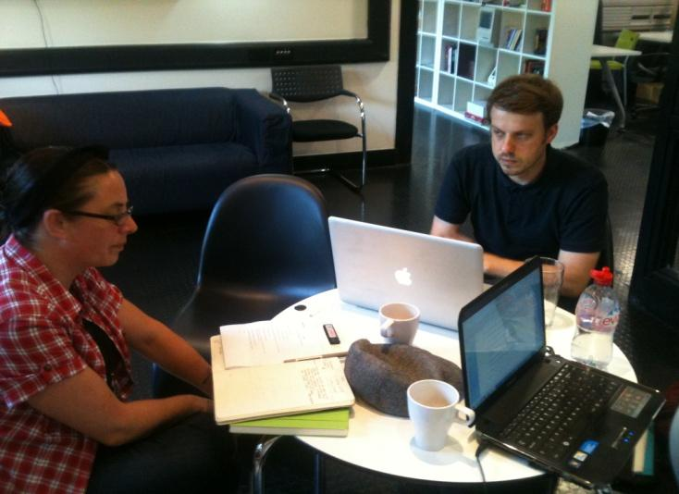
After...
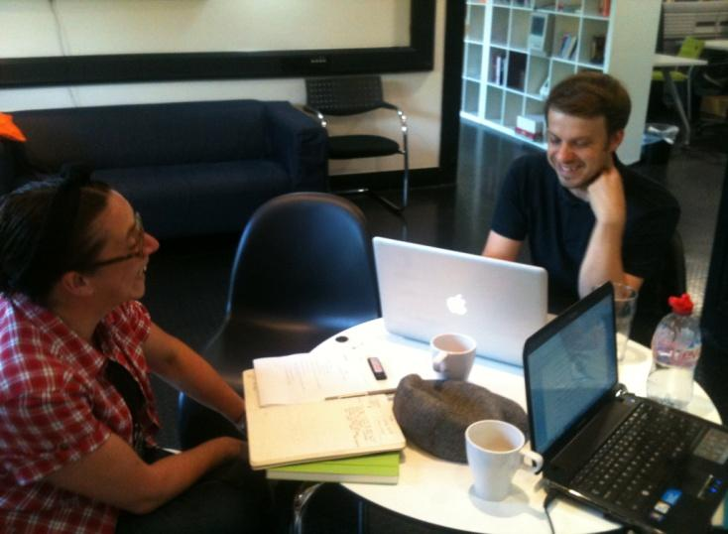
17th September 2012
No Sleep for these Dogs...
With everything back on track we’ve had a busy week. Sharon and Tom met up a few times midweek to work through the story – all is good, very good.
Tonight though was Sleepdogs’ night.
It’s great having them on board; their schedule is hectic so we’re lucky too.
We updated Tim & Tanuja on the project’s progress and recruited Tanuja to be Dramaturg and Director for the ‘showing’ later in the process. Other areas of discussion were;
- Expected timeline/schedule
- Establishing roles and responsibilities
- Aims and objectives – what questions are we asking in this period
There was a great moment after the meeting when Tim introduced us to the music he’d been working on. Sharon had previously briefed Tim on the essence of the Stick House; Tim took it and presented us with this....
http://du103w.dub103.mail.live.com/mail/#
http://sleepdogs.org/
The moment I refer to was Sharon’s reaction; it was the first time in this process I saw elation on her face. She whipped off her glasses and stared at me with such delight and punched the air...
I didn’t catch a photo of it but feel free to use your imagination with this one...
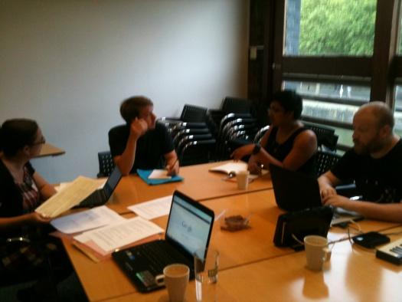

24th September 2012
A new addition
Another meeting with Sleepdogs and their understanding of the story is on point. So much so, I see it’s a struggle for Sharon to try and stay at the epicentre of the project. She wants to run with the narrative, Sleepdogs and all the creative fun it provides. Although she knows ideally her best position is straddling both the technological side that Tom presents with the theatrical side Sleepdogs are presenting.
It’s becoming clear the dynamic between Sharon, Tom and me lends itself to being honest about what we see is happening. Noting Sharon’s struggle with straddling both points seems to diminish the issue, which is good.
Welcome Tarim! Tonight we also met the new Creative Technologist Tom appointed, Tarim from Media Playgrounds. Yes, you’re right he wasn’t expecting the photo to be taken; a little surprised I’d say! Sorry Tarim...
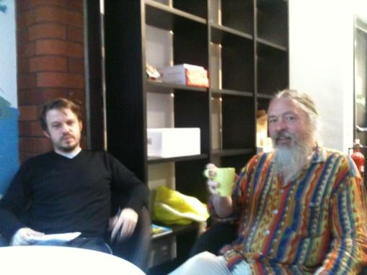

1st October 2012
I decided to spring an unexpected mini-evaluation on Tom and Sharon. Tom as sharp as ever retorted quite confidently with;
- Guidance
- Exposition
- Immersion
Get him.
This is all great as an Interim activity report is due into ACE.

2nd October 2012
Two great meetings today with Peter Clifford and Conor Murphy.
Peter we are hoping to consult with regards to cognitive behaviour and working with magic around audiences. Conor we’d like to call on his pretty amazing designing skills.
Both parties seem to be enchanted with the project so watch this space for developments....
http://bristolculture.wordpress.com/2011/12/16/review-peter-clifford-magic-crackers-brewery-theatre-bristol/
http://www.conormurphy.com/

8th October 2012
Short and sweet
Quick catch-up tonight – all plates spinning. I did push the audience numbers question again and I am forever pushing the venue question. I do have a few venues to look at this week big and small to cater for whatever is decided.

