POSTCARDS
FROM
CARNEGIE
HALL
A PROPOSAL BY RUTH FARRAR AND STAND + STARE

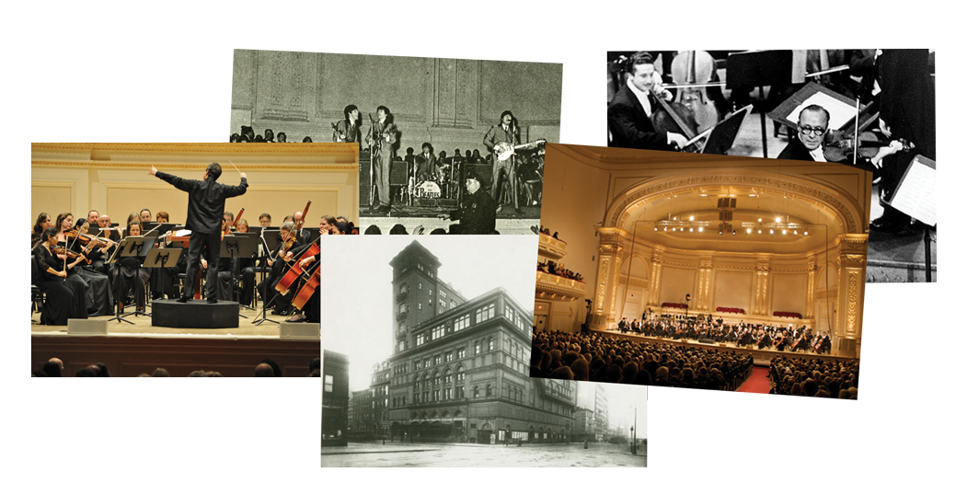

As you sit in the auditorium, wait in line at the box office or prop up the bar, have you ever wondered how many other Carnegie Hall visitors have stood in your shoes and how many stories must be sealed in the walls, if only they had a voice to tell them?

Postcards from Carnegie Hall unlocks 10 of those hidden stories through sound and animation via a new interactive app. Pick up real postcards at Carnegie Hall, hold them under the app, which recognizes the images, and watch as they spring to life. You can also use the app to view the stories wherever you are and send both real and digital postcards to your friends to tell them about your experiences.

OUR
PROPOSAL

In order to create something that can cross between the physical and the digital, an app is a good bridge. We propose to select strong images for up to 10 postcards, which illustrate a selection of audio stories about Carnegie Hall that we all want to tell. The sound and video content connected to these postcards could be accessed in several ways, both as an installation in Carnegie Hall (which is designed so it can be moved easily and set up in different locations throughout New York) and by anyone with a smart phone anywhere in the world, as outlined in more detail below:

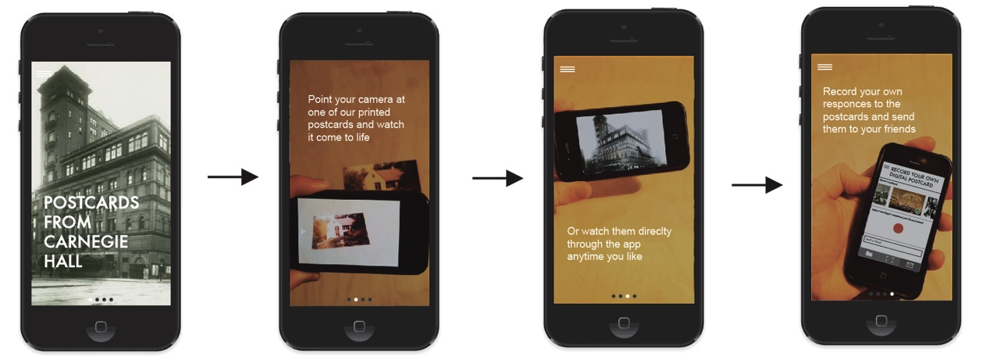

1. Printed Postcards
- Choose a printed postcard and scan the front image to activate its story. The app is primarily a viewer for an image recognition software programme (follow this link to see an example https://www.youtube.com/watch?v=oJbvy1v72ek). It recognises the postcard images and plays related audio and visuals. So, much like Theatre Jukebox (but through the screen), as you listen to the stories, you see animations layered within/on top of the postcards e.g. a sun rising over a photo of a hill or writing appearing on the card.
- Once the video has been activated, you can tap to see it full screen.
- The postcards could be freely available at Carnegie Hall and other venues to take home or post, available to buy in special presentation boxes and accessible via a special presentation installation (or installations) in the building or other venues.
- This would consist of an iPad (or iPads) mounted above a plinth with an incorporated postcard stand. Visitors would choose a postcard and place it under the iPad to activate the video within the app, probably listening through headphones. The installation would be relatively simple to design and build in New York with the option of having one or more depending on budgets.
- Text on the back of each postcard would explain how to download the app, to direct you it and the stories wherever you happen upon one.
- We would also include an invitation for you to write down your own story or experience of Carnegie Hall and mail the card to a friend.

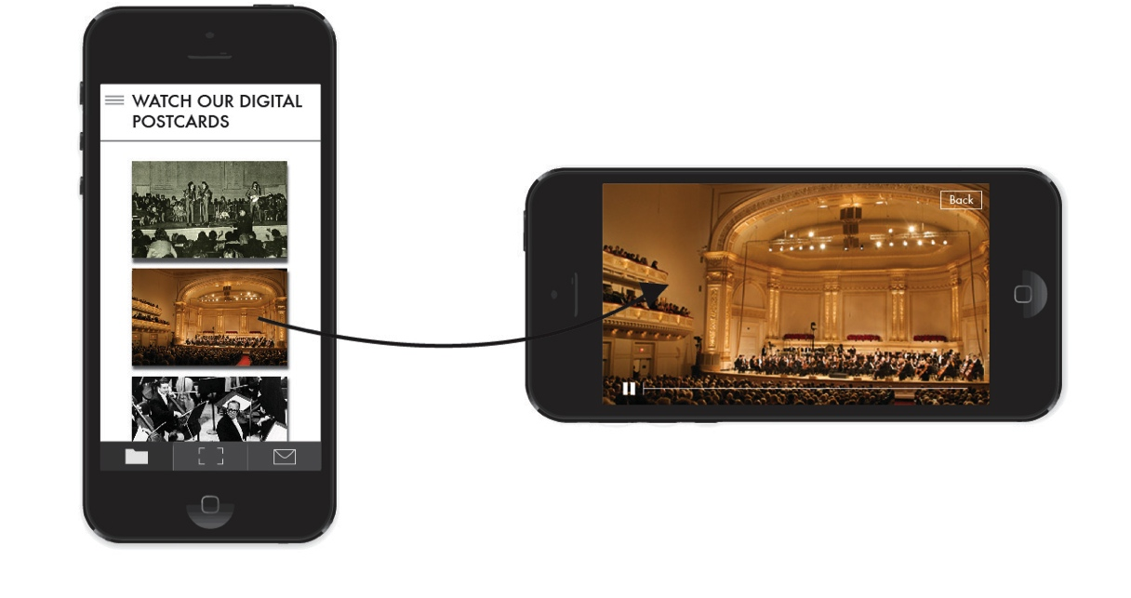
2. App Based Content Only
- Within the app, you will be able to select one of the images of the postcards to play the corresponding videos. These will appear in full screen mode. This enables people to access the stories anywhere, anytime, just without the novelty of using a printed, physical postcard to trigger the videos.

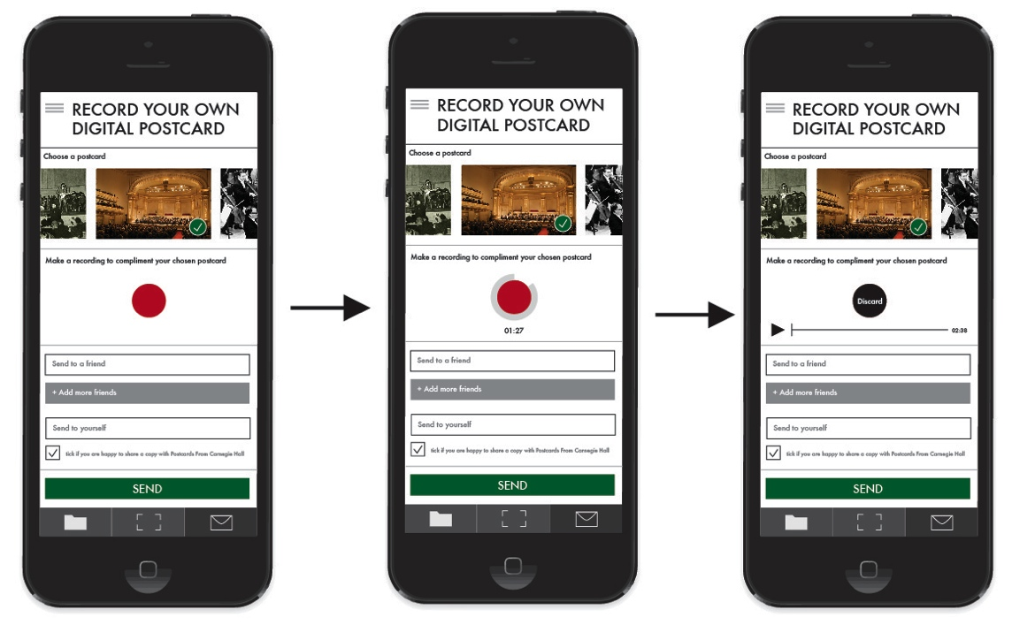

3. Digital Postcards – An Additional Function Within the App
- Within the app, you will be able to create your own digital postcards by selecting one of the postcard images, recording your own audio response to compliment that image, and sharing your recording and the image with friends.
- A tick box will allow you to choose whether you are happy to also share your digital postcard with Carnegie Hall. This could provide an interesting new method of collecting of visitors’ stories and responses.
- As with the printed postcards, the layout of the digital postcard will include a link to the app offering another way of guiding people to the stories.

4. Carnegie Hall Website
- A clear link on the Carnegie Hall home page (perhaps a postcard image) and a webpage within the site would explain the project. This would include clear instructions and a link to the app and potentially a short promo video of the app/installation in action to tempt people into experiencing it for themselves.

COST

1. QUOTE FOR IOS APP ONLY - NO STAND/INSTALLATION
Grand Total - £15,750

2. QUOTE FOR IOS APP PLUS ONE STAND/INSTALLATION
Grand Total - £18,000

Please see attached spread sheet and schedule for full breakdown

ABOUT
US

STAND + STARE

Stand + Stare create interactive installations, exhibitions and immersive performances. Their automated experiences are often based on historical material and memory, which has led them to work with museums, libraries, universities and a wide variety of organisations seeking innovative ways in which to open up their archives and collections.

Their work is showing in 2014/15 at:

Is this a Dagger? Barbican Centre, London: 29th Nov – 24th Jan
Blurring the Lines British Council HQ, Spring Gardens, London: 1 Oct – 19 Dec
I Will Always Have You Knowle West Media Centre, Bristol: 12 Sept – 19 Dec
Theatre Jukebox presents BAC, Battersea Arts Centre, London: permanent
Theatre Jukebox presents Oxford, Oxford Museum: permanent
Theatre Jukebox presents Mass Observation, The Keep, Brighton: 10 Oct – 3 Jan
Moving Conflict Museum of Science and Industry, Manchester: opens March 15

Find out more at: www.standandstare.com

Their preferred app developer would be Scott Evans of Segames Ltd, who they are currently working with on two other new apps.

RUTH FARRAR

Ruth Farrar has just completed an AHRC-funded PhD in immersive sound design and binaural technology application at University of Exeter. Her sound art work includes a sonic exploration of Bristol and Brooklyn by creating two audio postcards websites (www.audiopostcardsbristol.com and www.audiopostcardsbrooklyn.com) and a commissioned installation as part of Moving Sounds Festival 2013 at the Austrian Cultural Forum in New York. Ruth has also been commissioned to create and collaborate on two interactive classical music app prototypes for Bristol Proms and London-based the Orchestra of the Age of Enlightenment (OAE). Ruth’s sound design work for film has been screened at British Film Institute, Bristol’s Watershed Cinema and film festivals in Dublin, London, Cannes and New York.

Contacts:
Lucy Heywood: lucy@standandstare.com | + 44 (0) 7951 032 954
Barney Heywood: barney@standandstare.com | +44 (0) 7905 829 454
Ruth Farrar: ruthfarrar@gmail.com | +44 (0) 77516 730 895

