Proposal for Artprojx - Surround Sound artists project at Film at Art Basel in Miami Beach 2015.
Mariele Neudecker

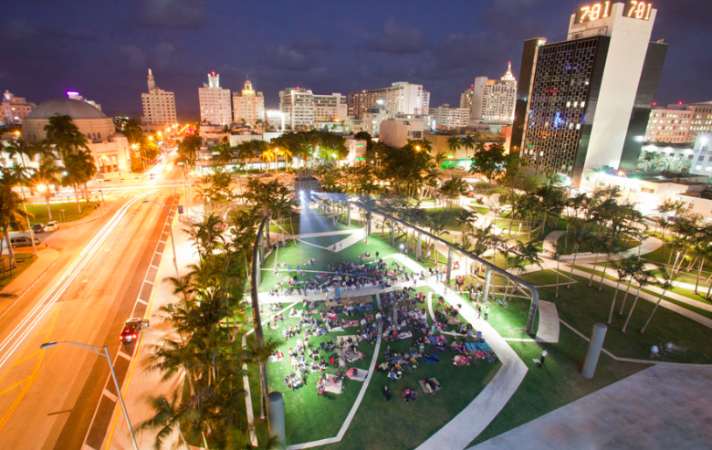

Figure of 8
(Rainforest, Ecuador, sound recorded at height: 1.39m, 9.78m, 22.59m, 30.79m and 37.26m)

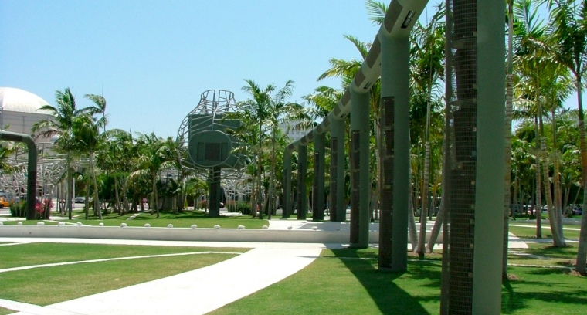
Surround Sound system of Soundscape Park, New World Symphony Center, Miami Beach

The prospect of over 160 speakers making up a surround sound is very alluring to me. The potential of experiencing something that can only work in situ, added to the impossibility or challenge to re-create or re-present this anywhere else in any way makes this event even more enticing.
Having worked with a film-project that was recorded in the backwater of the Ecuadorian jungle this summer, enables me to create and assemble soundtracks that layer up to a hyper-real 3-dimensional re-creation of specific jungle sounds.
The videos that were captured in Tiputini will be permanently installed to run in 3 lifts at the new Cancer Centre at Guy’s Hospital in central London. The lift height with its view out of a window onto the city will be synchronized with the height of the rainforest footage. We have recordings at five, sometimes more different specific heights, from the forest floor to above the canopy. These were captured at various times of the day, on many different days. The location: Tiputini Biodiversity Station [Ecuador], which is situated, is one of most bio-diverse rainforests in the world.

This ‘simulation’ aims to capture something unique: a soundscape that is artificially collaged from 3-dimensional sound-recordings sounds that, at the time of capture, observe and respond to the circadian rhythm. I am aiming to create a transient 3-dimensional sound space. It seems curious, that the biodiversity in Tiputini is captured with more clarity and complexity in the audio - than the video-recordings.

Not only am I interested in the clash of ‘urban’ and ‘natural’ wilderness, but also in the potential of animating the sound to imply a physical lift, shift through a slow, vertical descent and ascend – converted into a horizontal audio experience, that is possible to create with Surround Sound. One will sit still or walk in the arena, and ‘flow through’ the rich sound layers of the jungle. The constant and continuous change of the sounds communicates and resonates with the moving perception of the audience.

Mic used: Sennheiser MKH30 and MKH40 mic in a Rycote basket and suspension -
cardiod and figure 8 mic in MS configuration.

A big thank you for recording the sound in Tiputini go to Laurie Lax and John Taylor.
Other credits for making this work possible:
Guy’s and StThomas’ NHS Hospital Foundation Trust, London, UK
Guy’s and St Thomas’ Charity, London, UK
Bath Spa University, Bath, UK
Tiputini Biodiversity Research Station, Universidad San Francisco de Quito, Ecuador

MARIELE NEUDECKER

Born in 1965 in Düsseldorf, Germany, Mariele Neudecker lives and works in Bristol, UK. Neudecker uses a broad range of media including sculpture, film and photography. Her practice investigates the formation and historical dissemination of cultural constructs around the natural world, focusing particularly on landscape representations within the Northern European Romantic tradition and the notion of the Sublime.

Neudecker’s models, projections and installations of landscapes can be theatrically staged to reveal their own spectacular mechanisms. They are rendered in a precise yet slightly imperfect way as a means of strategically opening up a gap between the work’s material presence and the persuasiveness of its representation. Neudecker often uses technology’s virtual capabilities in order to reproduce a heightened experience of nature, thus addressing the subjective and mediated condition of any first hand encounter. Central to the work is the human interest and relationship to landscape and its images used metaphorically for human psychology. In some recent works, Neudecker has extended her investigation beyond the image to classical music, exploring the pathos and evocative power of works by Handel, Schubert, Mahler and Britten. With her body of work made in the NIKE Missile Site, Headlands, California in 2010, Neudecker’s artistic strategy is rooted in ‘ground truth’, a term used in remote sensing to describe data collected on location. Going beyond mere representation, Psychopomp (2010), her graphite rubbings of vast Hercules missiles, made whilst at the NIKE site, physically capture the object, making what is otherwise abstract and monstrous, tactile and present. In 2012 she went on an expedition to North West Greenland, and since then is also working with deep-sea marine biologist Dr Alex Rogers, Oxford.

Mariele Neudecker has exhibited widely internationally, including solo shows in Ikon Gallery, Tate St Ives, Tate Britain, and also in Biennales in Japan, Australia and Singapore. She has made a number of public commissions and won a variety of prizes, residencies and is included in numerous collections, publications, catalogues and essays. In 2010 she was shortlisted for The Fourth Plinth, Trafalgar Square, London.
Solo exhibitions include Hinterland, Mariele Neudecker, Kunstmuseum Trondheim, curated by Pontus Kyander, Norway, Heterotopias and Other Domestic Landscapes, Brighton Festival, lead artist for HOUSE, Brighton, Parhelion (2012), Thomas Rehbein Gallery, Cologne, Mariele Neudecker, Galerie Barbara Thumm, Berlin (2010);
Group exhibitions include MODEL, Galerie Rudolfinum Praha (2015), ANTARCTROPIA at the Antarctic Pavilion at the Venice Architecture Biennale (2014), ARCTIC, Louisiana Museum of Modern Art, Humlebaek, Denmark (2013), Otherworldly: Artist Dioramas and Small Spectacles, MAD Museum, New York, USA and GSK Contemporary: EARTH: ART IN A CHANGING WORLD Royal Academy of Arts, London, UK (2009).

Amongst other projects, she is currently working towards a Solo exhibition at the ZEPPELIN Museum in Germany, and this [above mentioned] public art commission at Guy’s Hospital, London. The commission has four components inter-connected by an overall sense of a parallel between the Cancer Clinic as part of the urban jungle and the growth pattern in a full height rainforest.

www.marieleneudecker.co.uk
http://www.guysandstthomas.nhs.uk/home.aspx
http://www.charitychoice.co.uk/guys-and-st-thomas-charity-1812
www.bthumm.de
www.rehbein-galerie.de

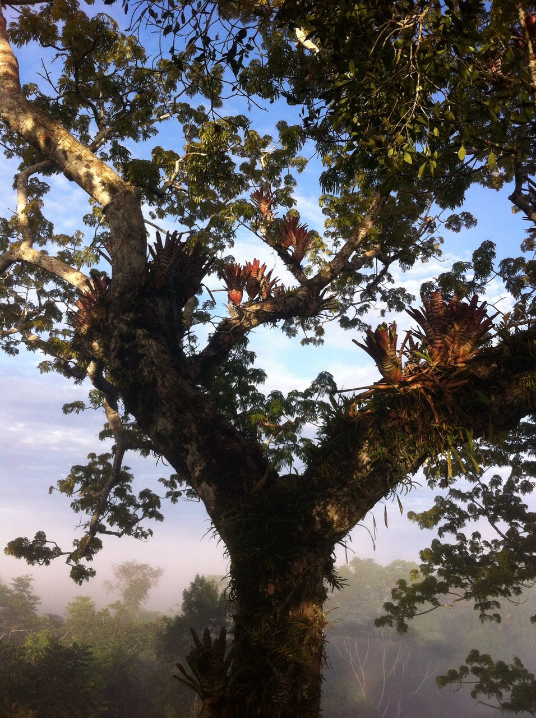
Tiputini Biodiversity Research Station, image © Laurie Lax

