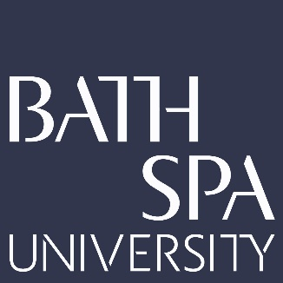
School: School of Creative Industries
Researcher: Dr. Ruth Farrar
Project Title: Dear Carnegie Hall
UOA: 34
Knowledge Dissemination
Research insights gained from making Dear Carnegie Hall were shared and developed in three impactful ways:

- An Invited Key Note Speech at The International Academic Forum (IAFOR) Conference in Kobe, Japan.

I chose to deliver my keynote speech as an interactive workshop with my industry partner Barney Heywood from Stand + Stare to encourage active learning and engagement.

This method led to documented attendee feedback demonstrating how insights, research tools and new media technologies shared during the workshop may be applied to attendees’ own research to enrich several projects ranging from a monograph book to a PhD thesis.
Post-conference, it also developed university teaching practice as one attendee, a Professor from the Phillipines, applied insights gained to an interactive lecture he gave on fashion history.

- An academic article published in the International Journal for Media Research: Issue 3 April 2020.

Key research findings demonstrate how using new digital technologies can encourage a
sense of play with the seemingly fixed stories of history. The outlined methods also lead
to increased participant engagement and a deeper multi-layered understanding
of an organisation’s rich layered history. The techniques employed in this app effectively
provide a solution for the challenging yet important task of documenting multiple diverse
perspectives of the past.

3) Research gained from the process led to securing future industry commissions.

Dr. Ruth Farrar and Stand + Stare hold the intellectual property rights for the app’s design
and development, which were then utilised on future funded projects in industry such as
Stand+Stare’s app The Illuminators of Aberdeen. This interactive app unlocked the stories of
six remarkable innovators from Aberdeen’s past for Spectra: Aberdeen’s Festival of Ligh

