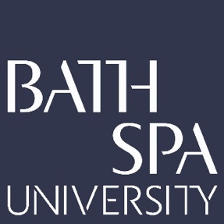
School: Creative Industries
Researcher: Ruth Farrar
Project Title: Shextreme: Creating Impact Through Participatory Action Research: a film festival framework case study
UOA: 34
300-Word Statement

‘Shextreme’ is a participatory action research project (PAR). It identifies and investigates a film festival framework for researchers seeking impact. It examines how a film festival can play an active, progressive role in improving the representation of women in adventure films, on-screen and behind the camera. The resulting multi-component output is ‘Shextreme Film Festival’, the world’s first film festival celebrating women in extreme adventure sports, in Bristol since 2015, with film tours in UK and France. Contextual information comprises festival video documentation, its responses plus a journal article that uniquely contributes to PAR.

Data was gathered from attendees, filmmakers and a survey – developed with industry partner Women in Adventure (2,700 responses from 12 countries). Supported by industry partners including British Film Institute, Rab and Salomon, ‘Shextreme Film Festival’ emerged as a case study using PAR to enact substantial public and industry change.

Research insights can be applied widely to benefit arts, humanities and science scholars seeking research impact. A film festival framework provides evidence of co-impact and is a novel participatory approach to research impact.

The project's intellectual significance is the addition of new knowledge to PAR applying PAR terminology to the adventure film industry to support meaningful academic engagement with industry.

It is also significant socially. It can positively change attendees' behaviours. Post-watching Shextreme Film Festival, women spent more time outdoors participating in adventure sports, increasing women's mental wellbeing.

Economically, this research introduces new enterprising solutions for academics to sustainably fund long-term impactful projects.

Findings were disseminated via a report distributed to adventure industry partners USA’s Outdoor Women’s Alliance, who utilised the research to encourage female participation in the outdoors. Research was published in Research for All journal. Finally, in response to a PAR approach, Farrar launched ‘Shextreme Alliance’, the first international network for female adventure filmmakers.

