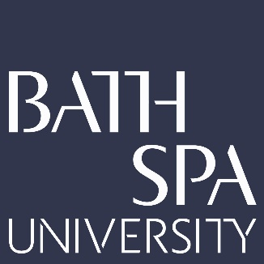
School: School of Creative Industries
Researcher: Dr. Ruth Farrar
Project Title: Shextreme – Creating Impact Through Participatory Action Research: a film festival framework case study
UOA: 34
Research Timeline
Date | Rationale of research activities and decisions undertaken
2014 - 2015 | Shextreme Year 1: Initial Research & Data Gathering  Created an online archival collection of women in extreme sports and adventure: www.shextreme.tv  Responded to feedback to meet in person, which took the shape of Shextreme Film Festival.  I launched the world’s first film festival celebrating women in extreme sports and adventure: Shextreme Film Festival in Bristol U.K.  I examined if attending the festival led to an increased awareness and understanding of women in extreme sports.
2016 | Shextreme Year 2: Focus on Filmmakers and International Audience Development  Based on audience feedback, I produced the first Shextreme Film School as part of Shextreme Film Festival’s programming. After its success, Shextreme Film School continues to run as part of the festival’s annual programme.  I developed an international audience reach when I was invited to become the film partner of Full Screen Tour: a touring creative programme of original art, music and film in the French Alps in March, 2016. This involved pop up screenings followed by a Q & A at each tour stop with world-record breaking athletes, adventurers and Olympians including Squash Falconer, Emily Sarsfield and Kat Follows.
2017 | Shextreme Year 3: South West UK Audience Development and Mental Wellbeing Survey Launch  Based on audience feedback and examining current trends emerging in submitted content, I launched the world’s first survey on women in adventure’s mental wellbeing at Shextreme Film Festival 2017. This survey was designed in collaboration with Hetty Key from the research organization Women in Adventure.  Pre-survey, we signed industry partners for the survey to ensure the research being carried out was meaningful and beneficial in industry and communities supporting women in adventure sports.  Shextreme Film Tour received funding from the British Film Institute’s Film Audience Network to produce a film tour in the South West, U.K. aimed at attracting younger audiences to the cinema and improving the representation and awareness of women in extreme sports and adventure.
2018 | Shextreme Year 4: Shextreme Alliance  The results of the research survey, over 2500 participants worldwide, were processed.  I secured a second round of funding to run Shextreme Film Tour in March 2019.  Screenings in 2019 were examining if attending Shextreme Film Festival changed behavior  Based on audience feedback and industry needs, I founded Shextreme Alliance: the world’s first international network supporting and training female adventure filmmakers and photographers. Shextreme Alliance was launched at Shextreme Film Festival 2018.
2019 - 2020 | Shextreme Year 5: Audience Expansion, Research Gathering and Results Dissemination  Women in Adventure’s mental wellbeing survey results were published on International Women’s Day.  Shextreme Film Festival expanded its programme to reflect the survey’s findings producing a new screening entitled Wheels, Waves and Wellbeing.  Shextreme Film Festival 2019 partnered with Watershed Cinema in Bristol.  I created the 16mm documentary film Nurture in response to the survey findings.  Shextreme Alliance launched workshops in mountain biking and adventure photography training up more women behind the camera in the U.K. and France.  Shextreme Film Tour expanded its touring programme from the South West going nationwide to twenty cinemas in Wales, Scotland, England and Northern Ireland.

