MARIELE NEUDECKER
From the Amani Vanitas series
Exhibited at the NUNNERY GALLERY, Bow Arts, London in
Traces of the Future: Archaeology of Modern Science in Africa
28 January - 27 March 2017

1
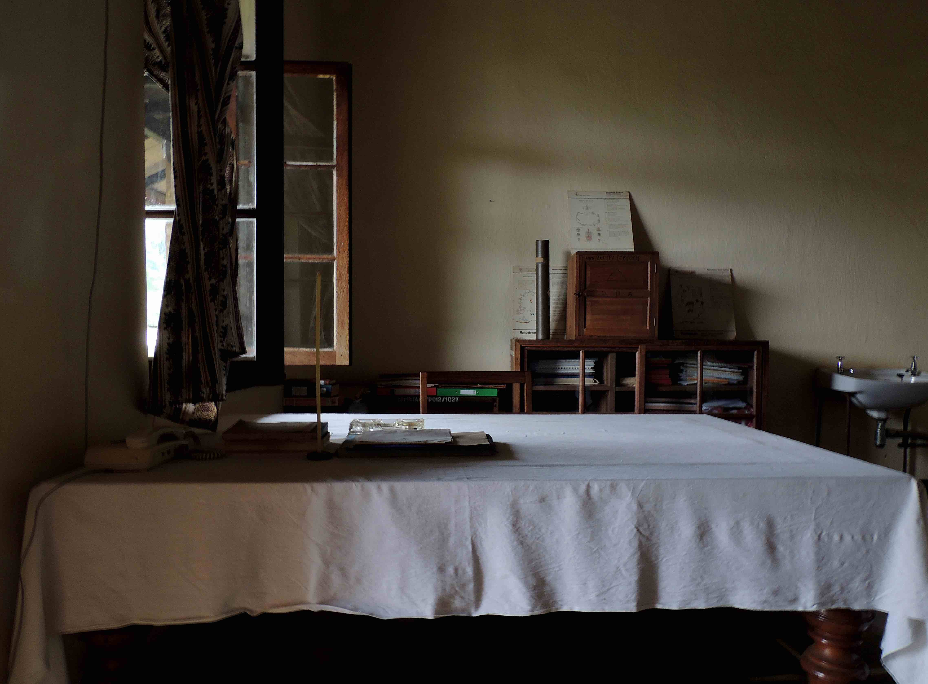
Amani Vanitas [office 1]
2014/17
Fine Art Print [Photo Rag Baryta]
59.4 x 42 cm
Edition 2/5

2
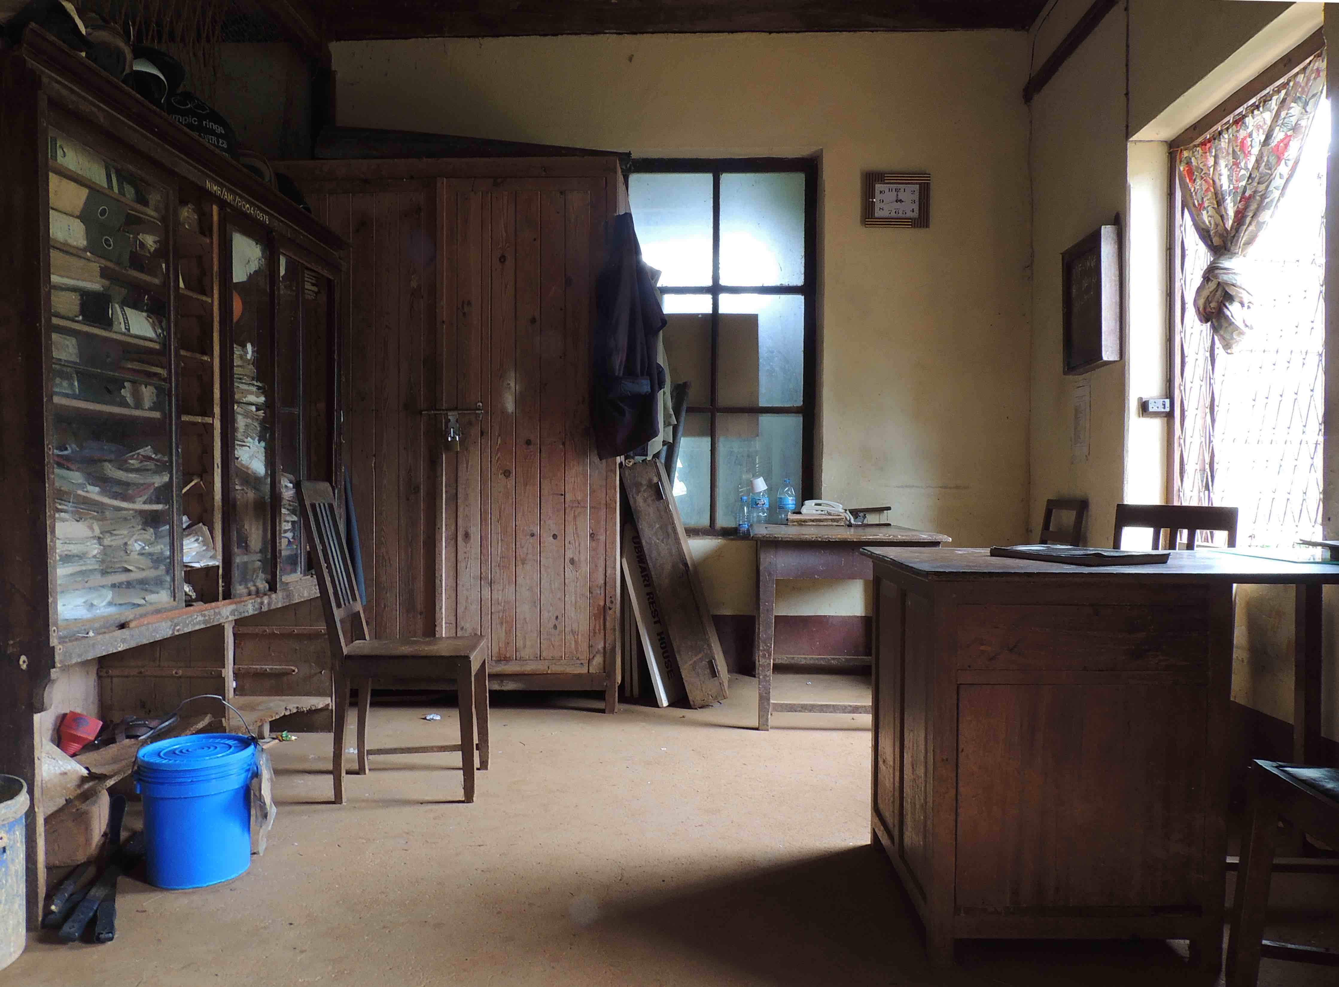
Amani Vanitas [office 2]
2014/17
Fine Art Print [Photo Rag Baryta]
59.4 x 42 cm
Edition 2/5

3
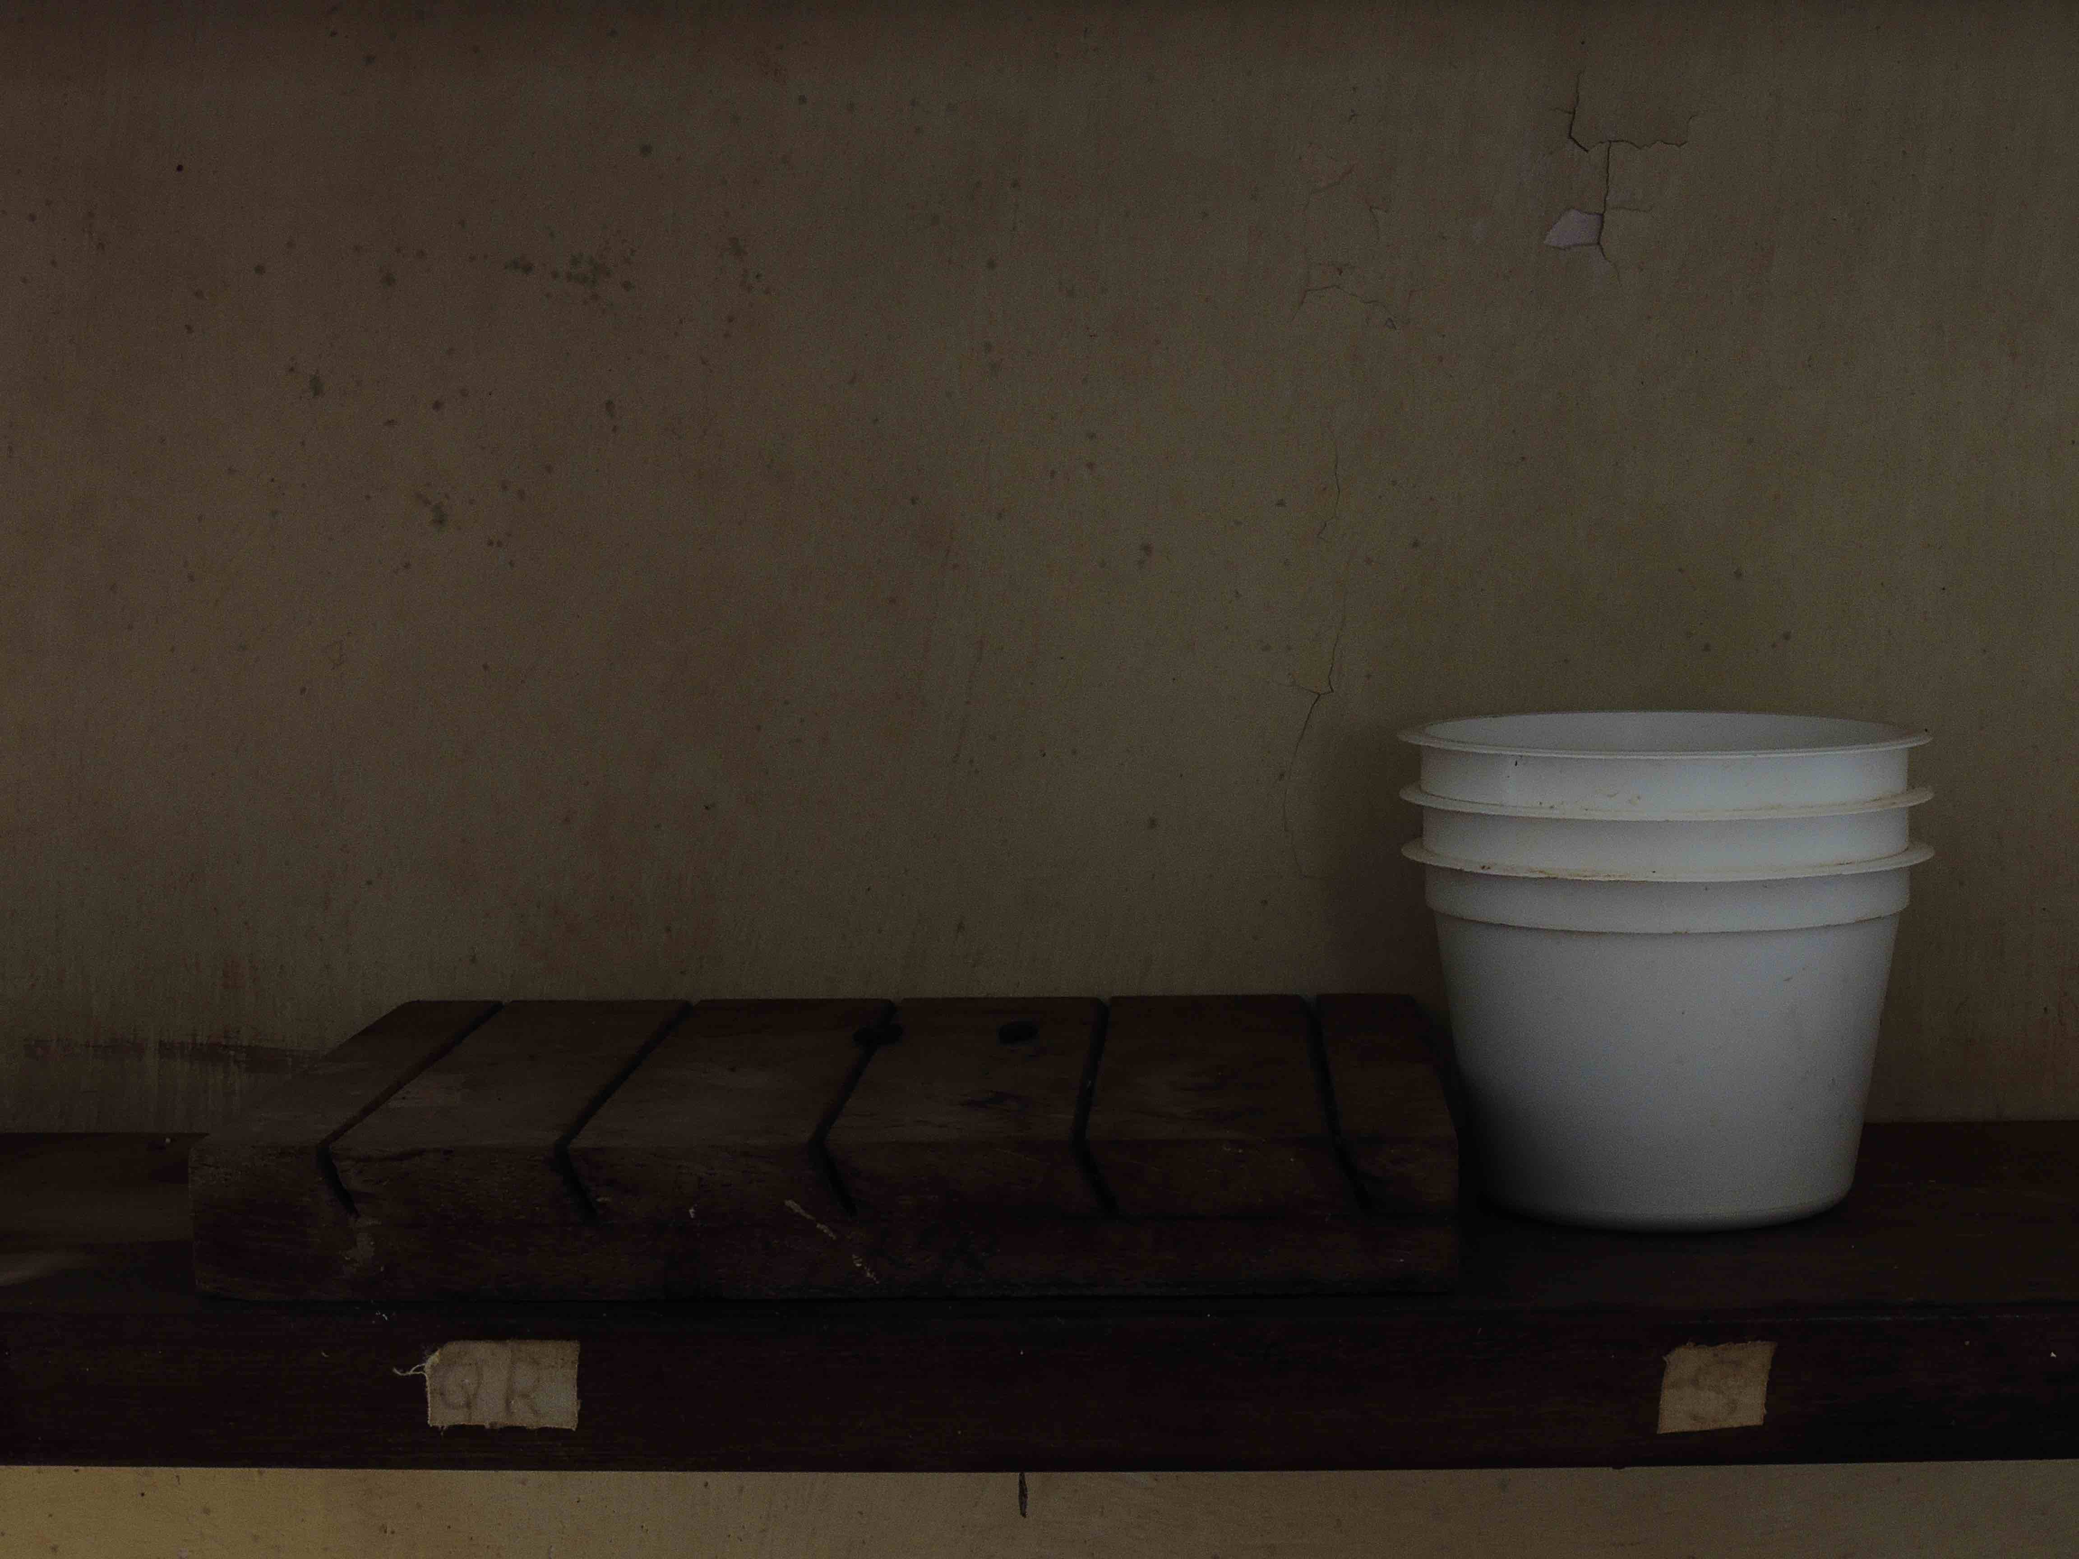
Amani Vanitas [3 cups]
2014/17
Fine Art Print [Photo Rag Baryta]
59.4 x 42 cm
Edition 2/5

4
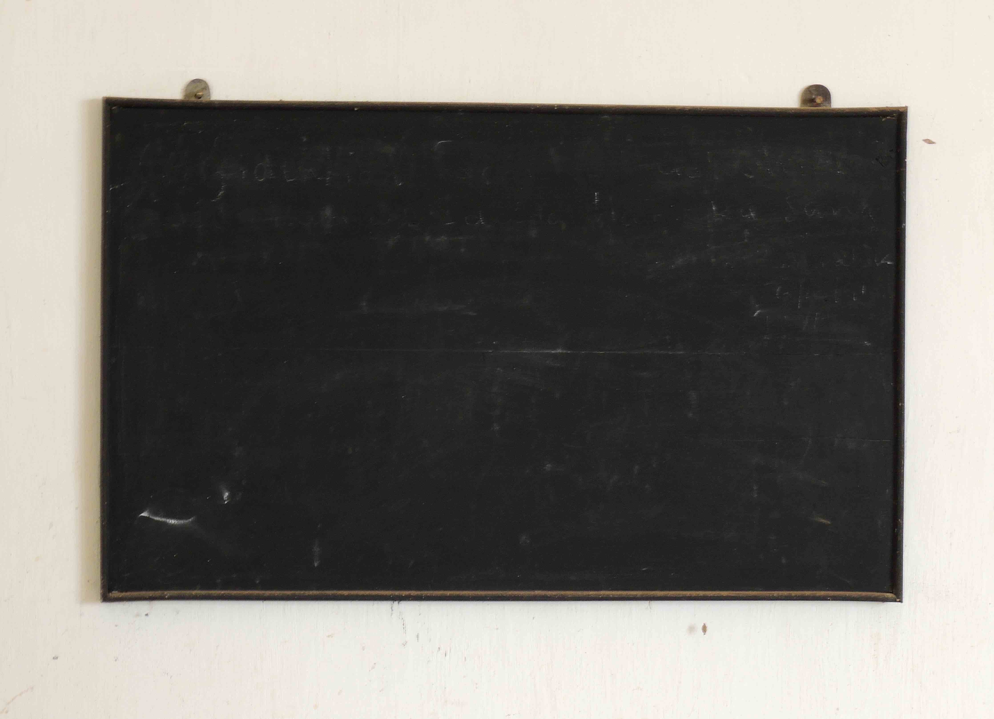
Amani Vanitas [blackboard]
2014/17
Fine Art Print [Photo Rag Baryta]
59.4 x 42 cm
Edition 1/5

5
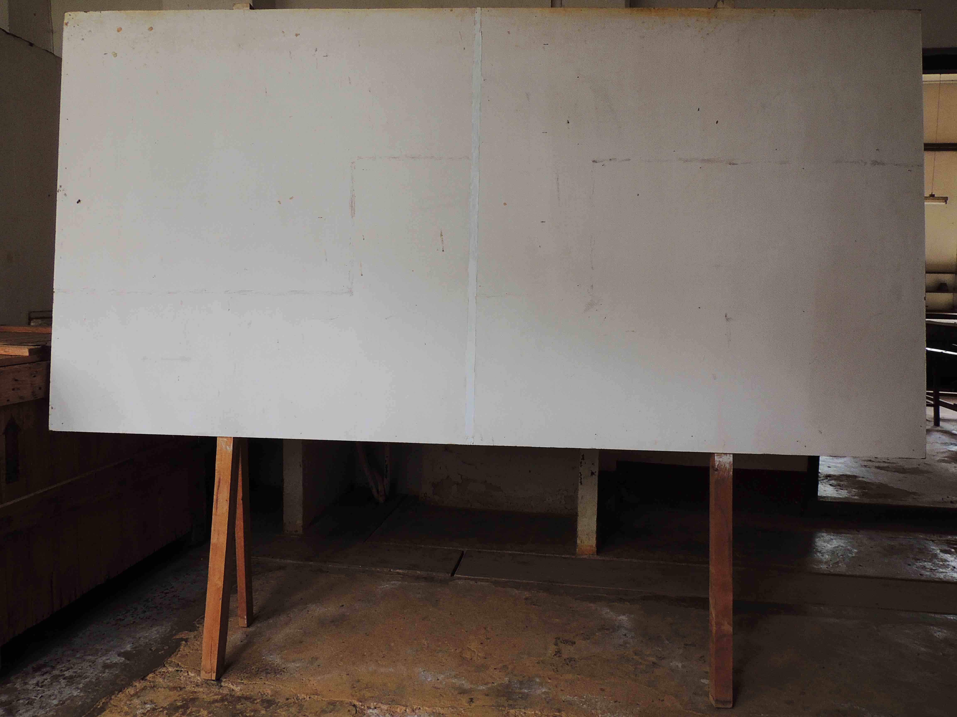
Amani Vanitas [board]
2014/17
Fine Art Print [Photo Rag Baryta]
59.4 x 42 cm
Edition 1/5

6
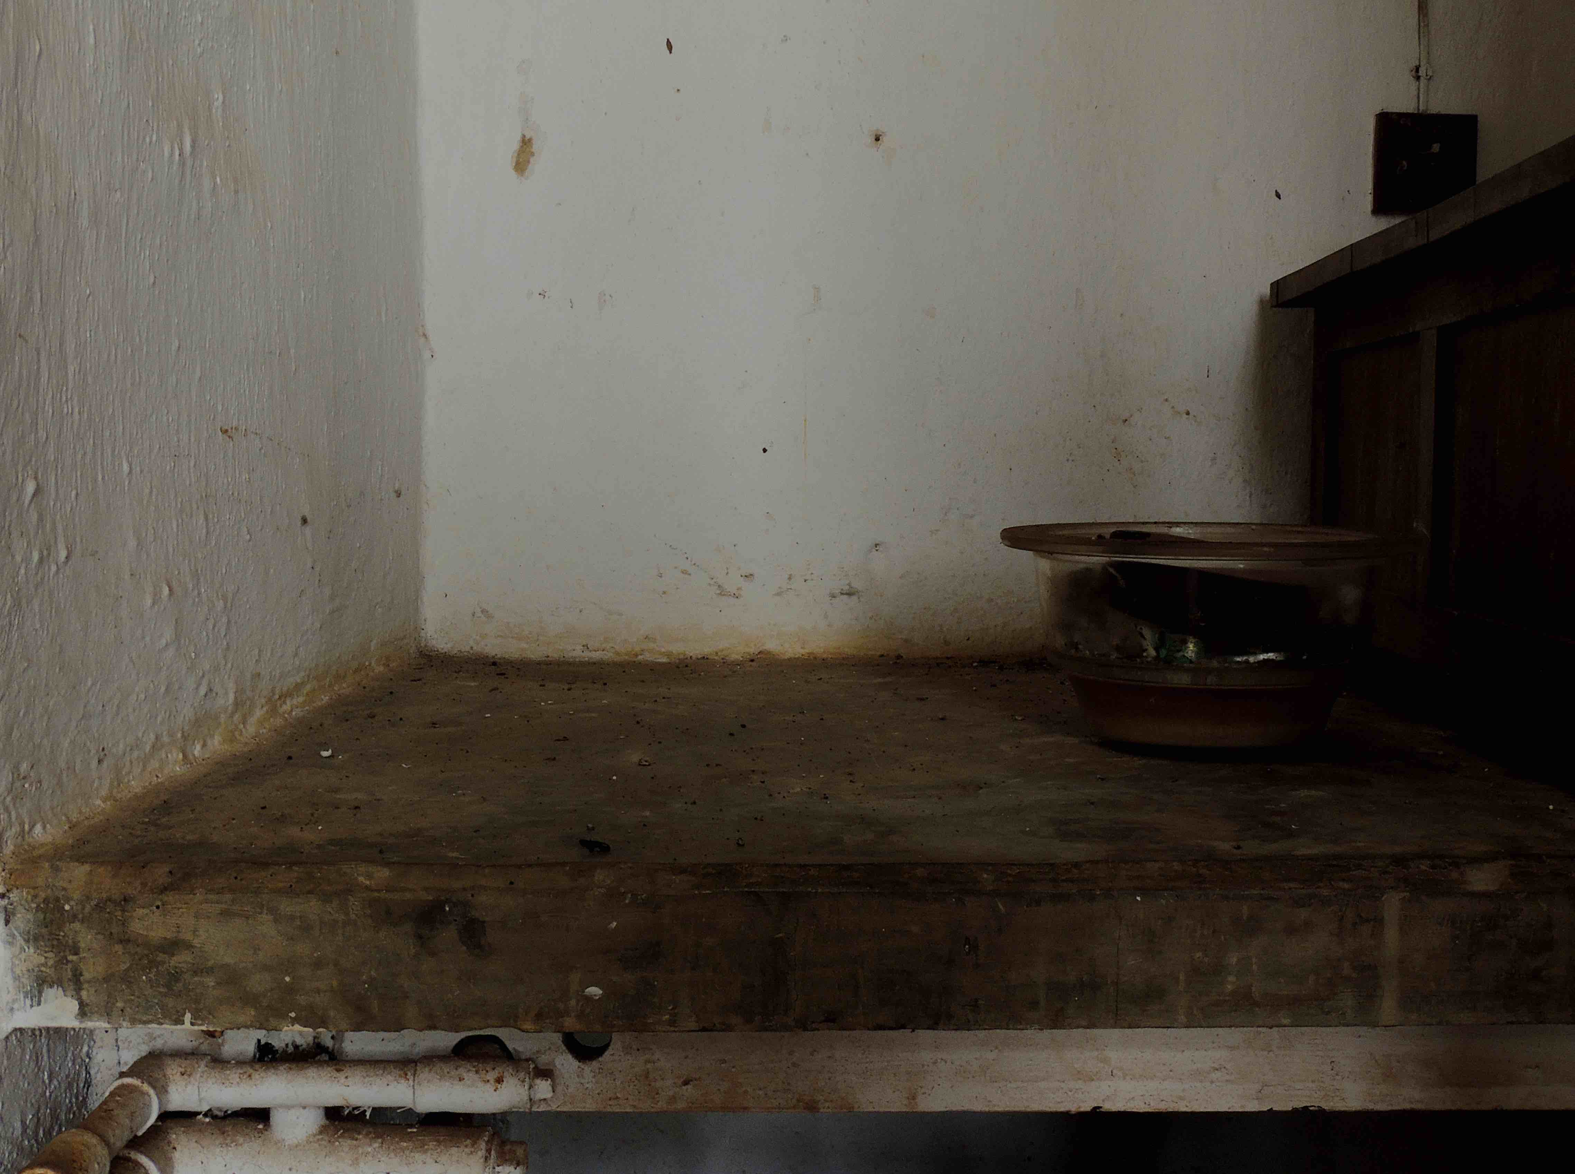
Amani Vanitas [corner]
2014/17
Fine Art Print [Photo Rag Baryta]
59.4 x 42 cm
Edition 1/5

7
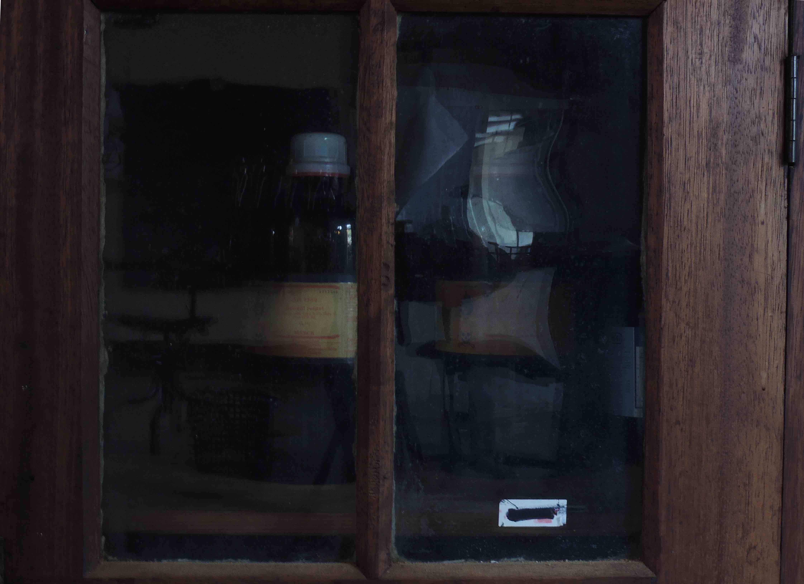
Amani Vanitas [cupboard]
2014/17
Fine Art Print [Photo Rag Baryta]
59.4 x 42 cm
Edition 1/5

8
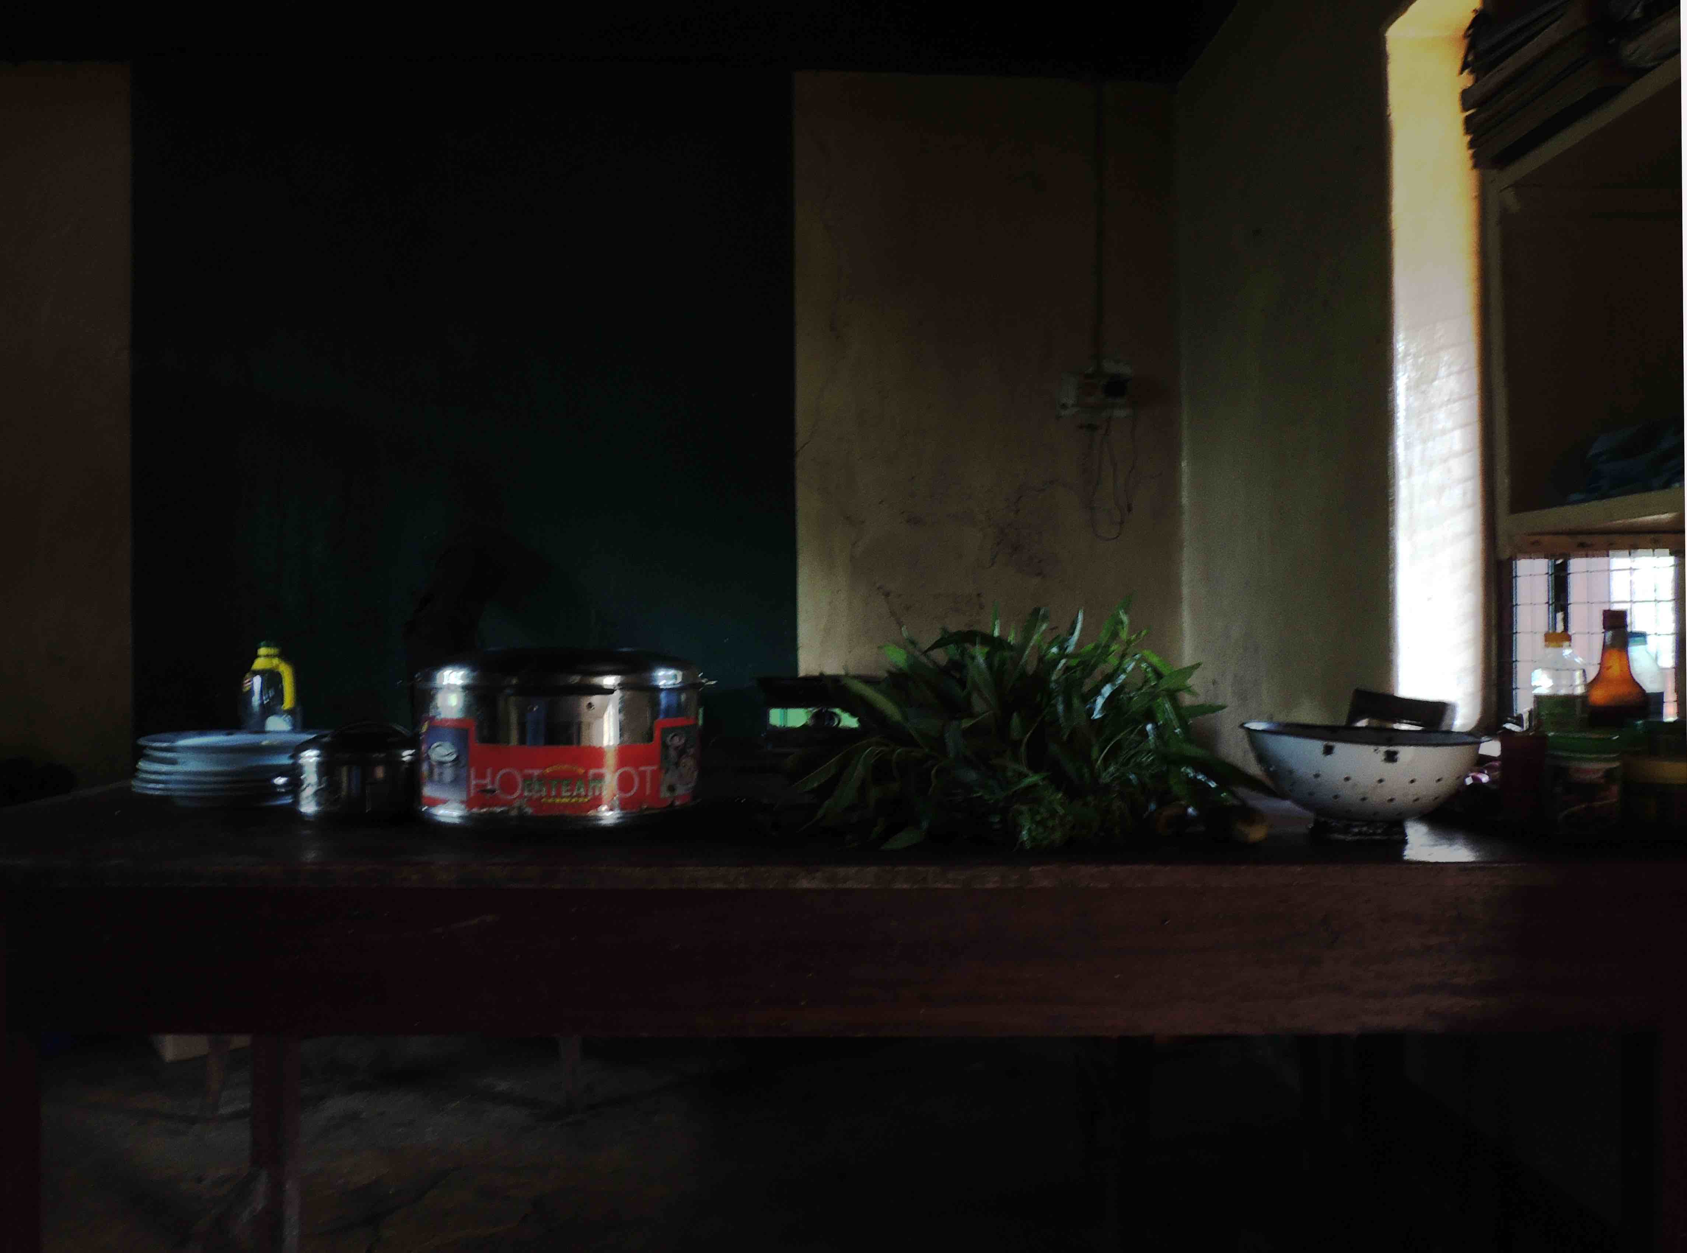
Amani Vanitas [kitchen]
2014/17
Fine Art Print [Photo Rag Baryta]
59.4 x 42 cm
Edition 1/5

9
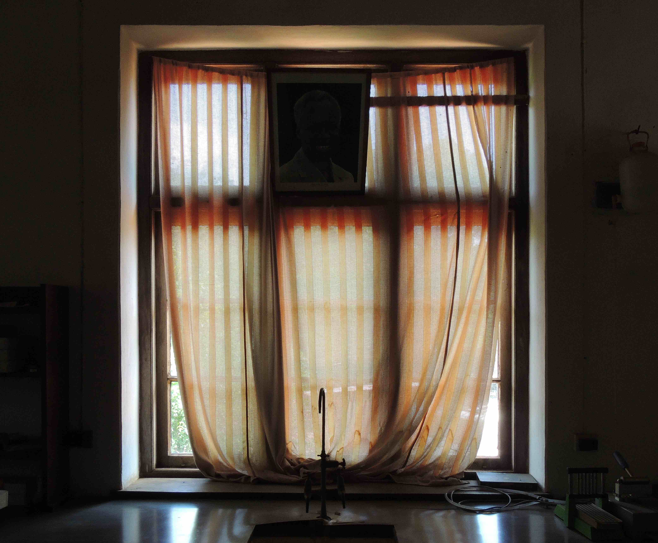
Amani Vanitas [curtain]
2014/17
Fine Art Print [Photo Rag Baryta]
59.4 x 42 cm
Edition 1/5

10
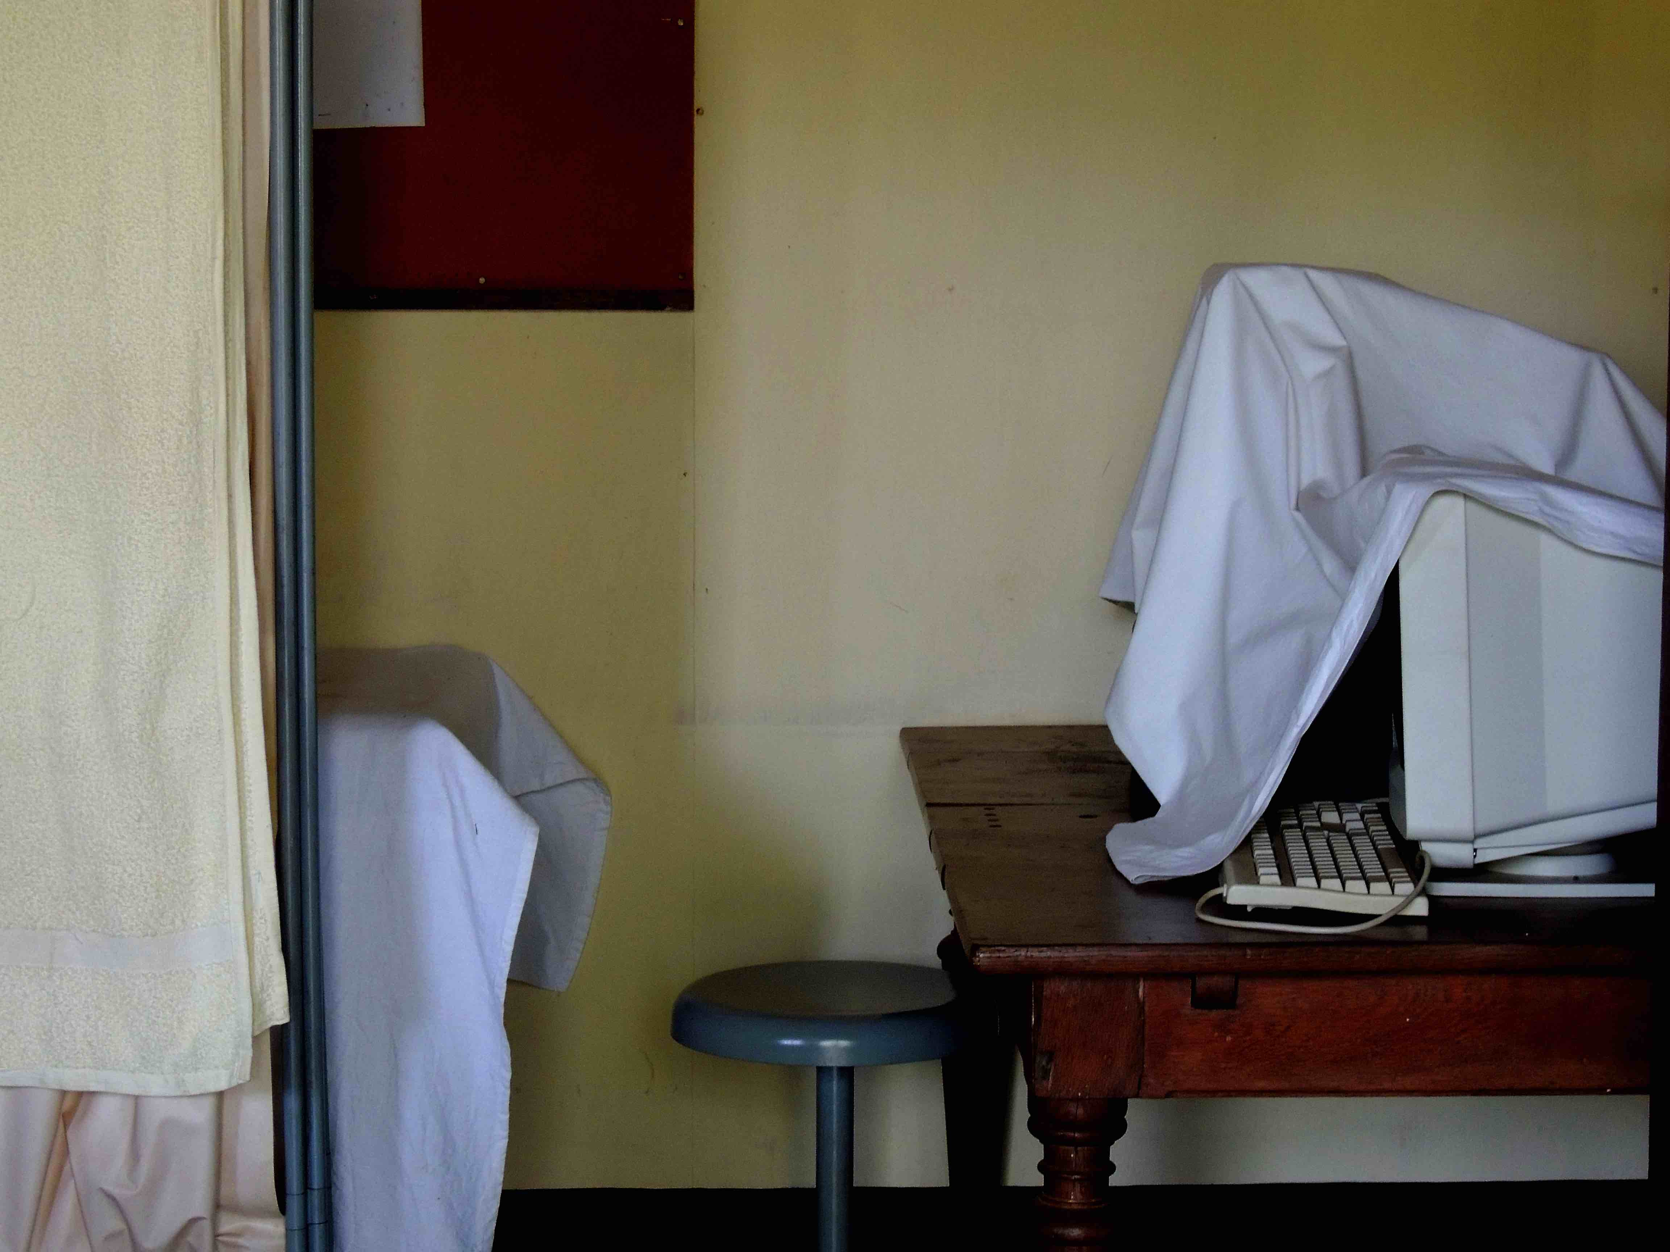
Amani Vanitas [computer]
2014/17
Fine Art Print [Photo Rag Baryta]
59.4 x 42 cm
Edition 1/5

11
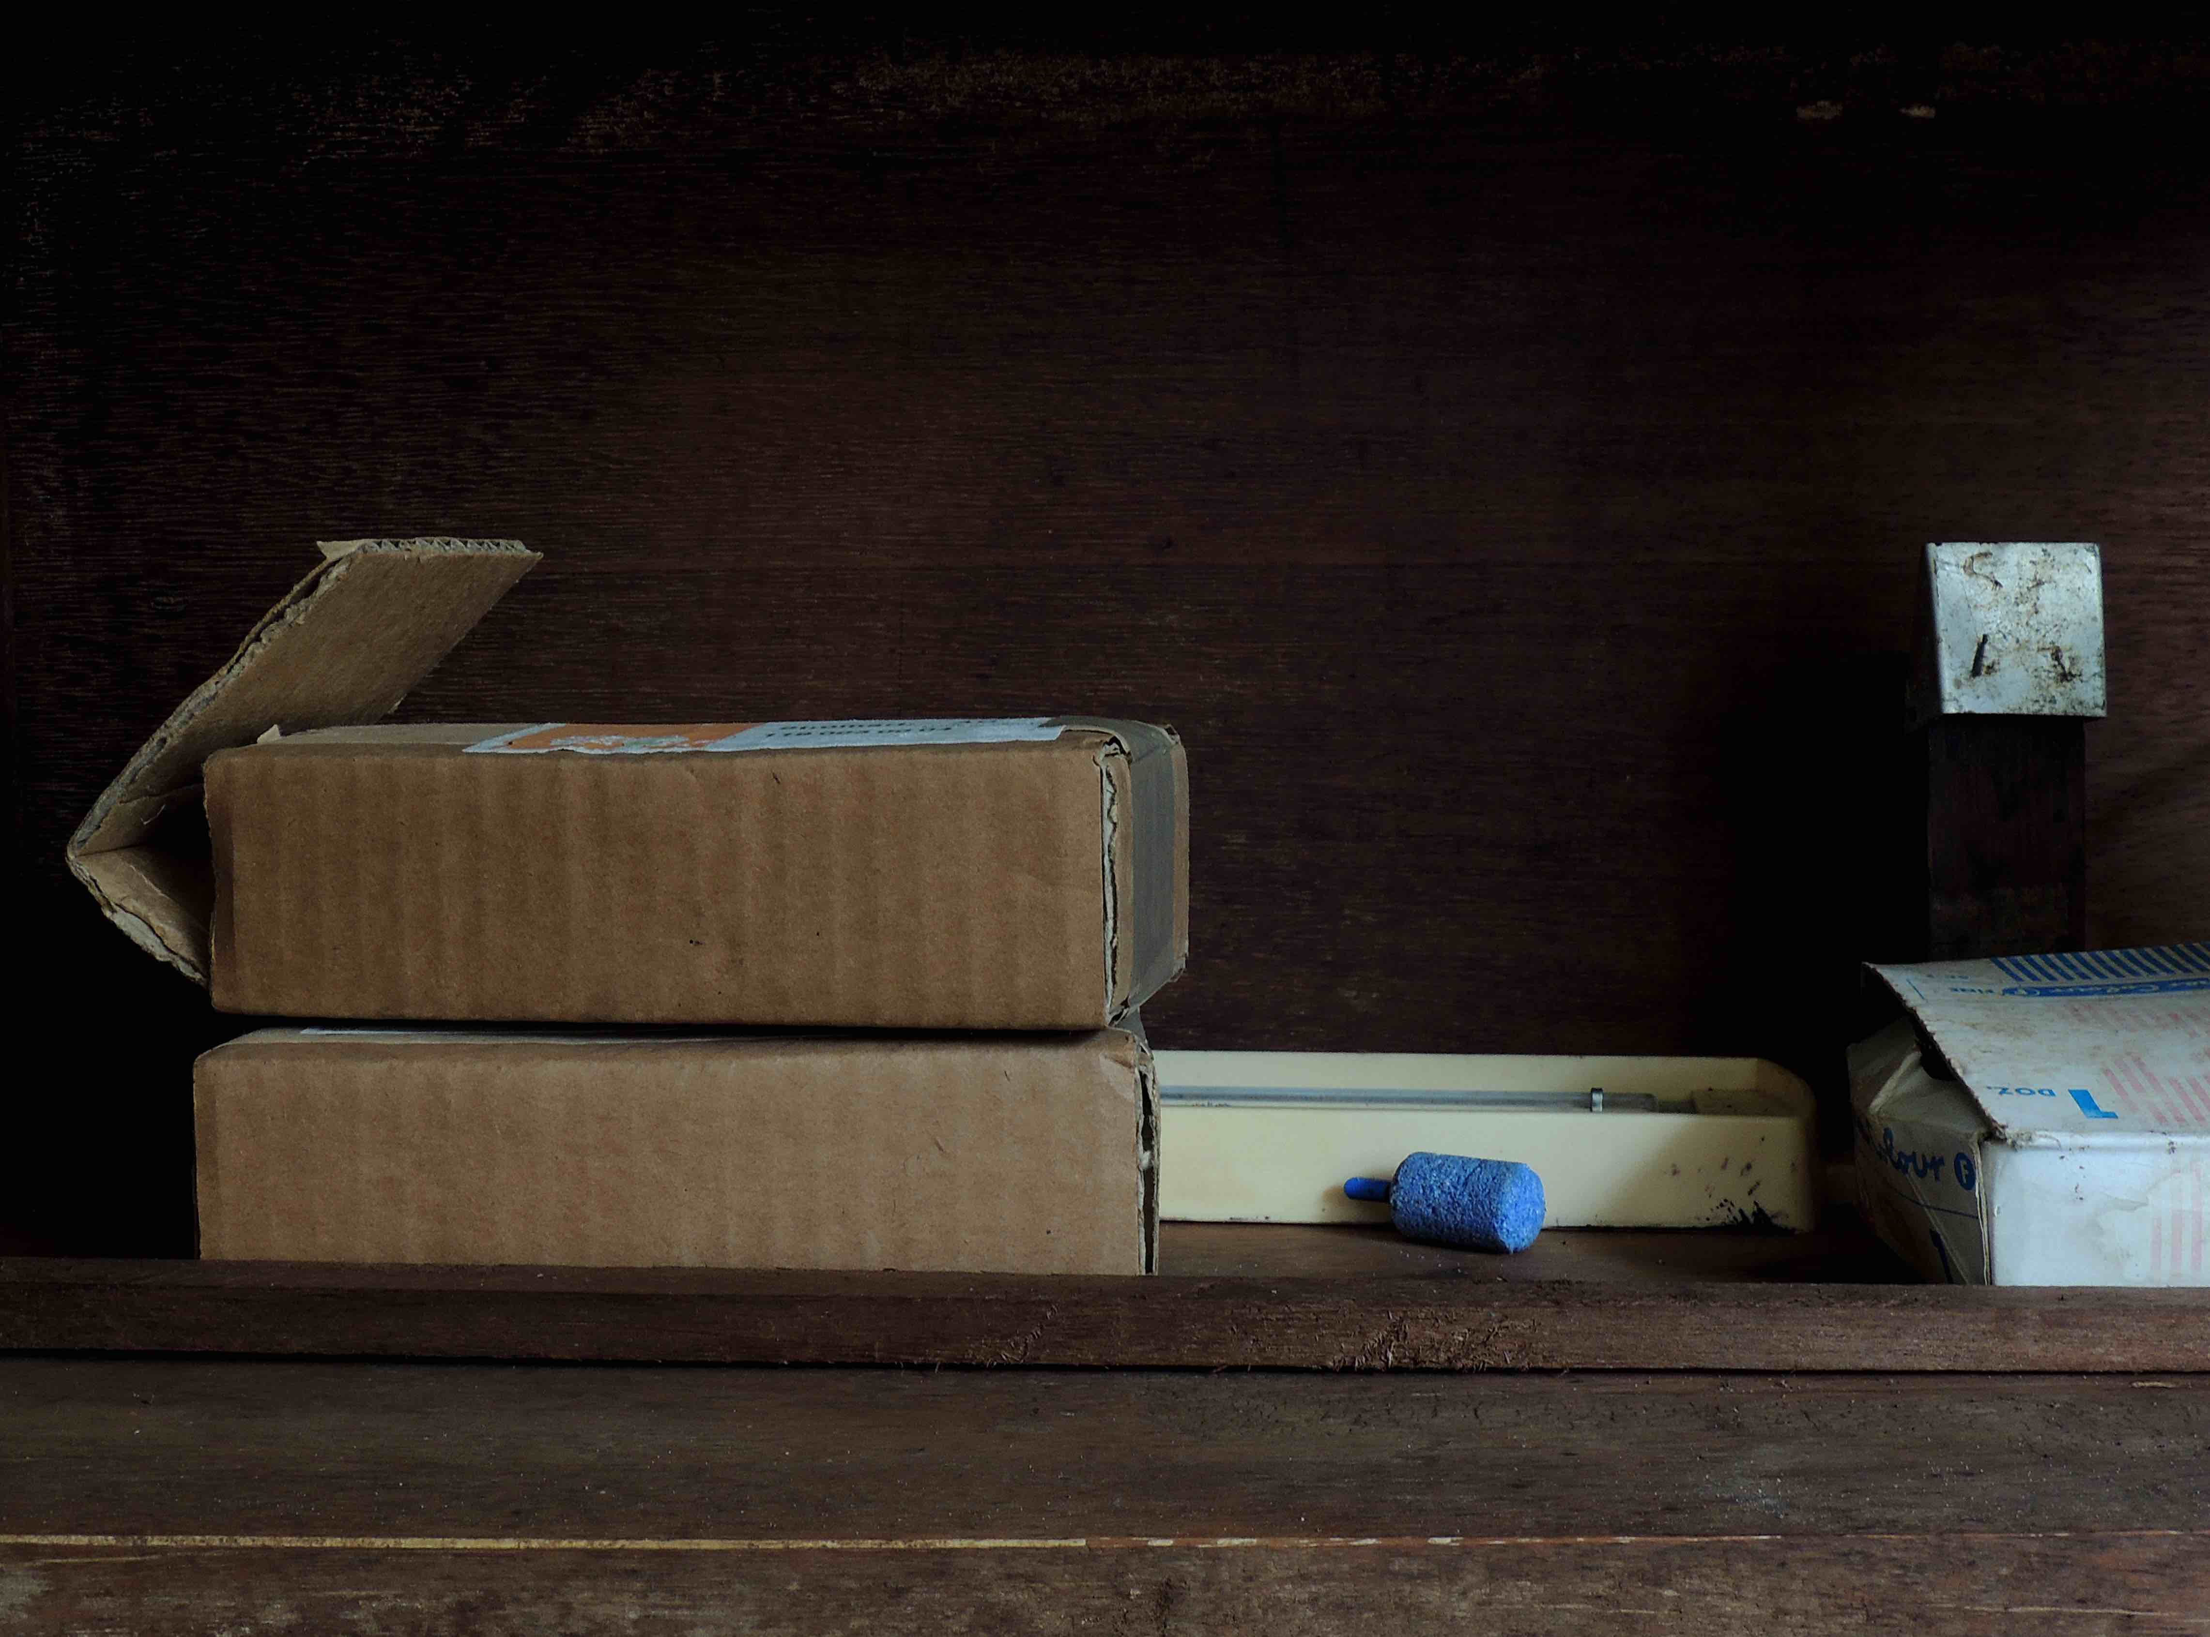
Amani Vanitas [chalk]
2014/17
Fine Art Print [Photo Rag Baryta]
59.4 x 42 cm
Edition 1/5

Videos:
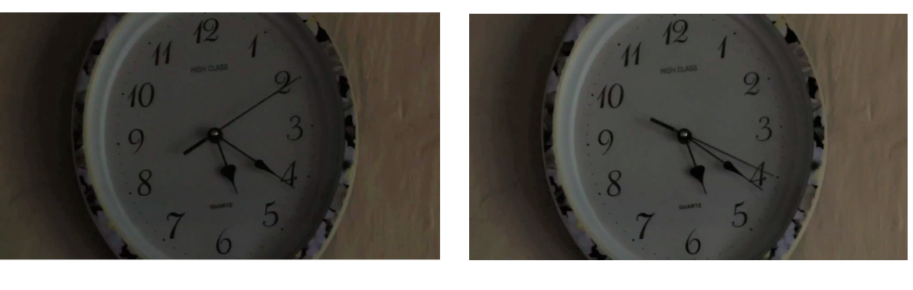
Six More Weeks
2014/17
pair of 4’ 43” and 51” videos on loop

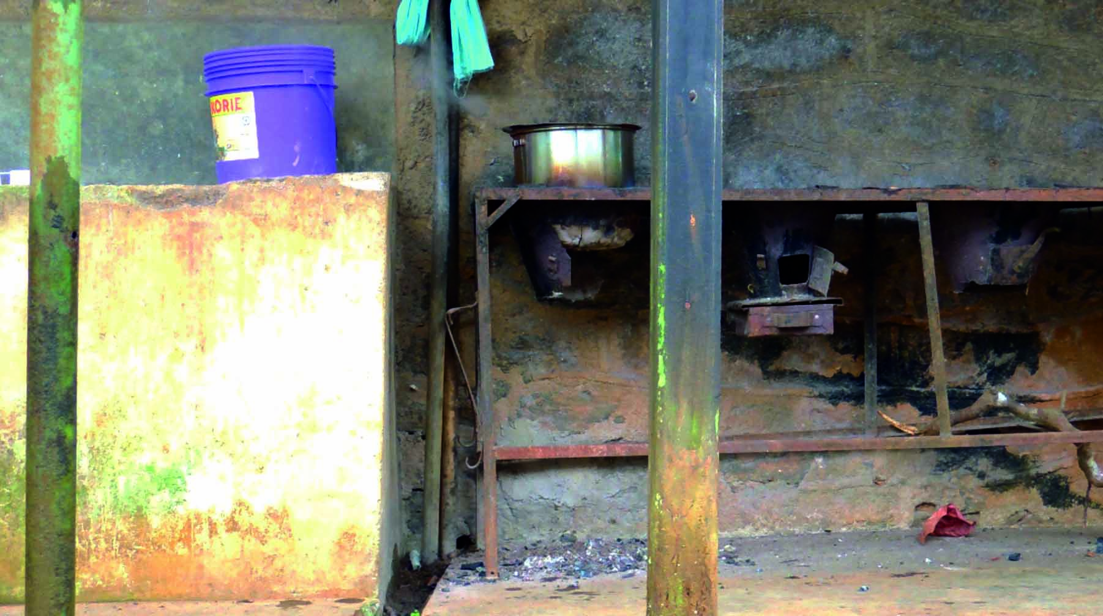
Amani Vanitas [pot]
2014/17
0’24” video on loop

Amani Vanitas [office]
2014/17
1’ 14” video on loop

MN Jan 2017

