UGO 0.2
Project Space

BA [Hons] Fine Art
University Centre Colchester
School of Art

_ _ _ _
.

UGO 0.2 was kindly supported by the UCC Research Fund 2018-19.

INTRODUCTION

UGO 0.2 Project Space
CONTENT:
The BA [HONS] Fine Art undergraduate programme within the School of Art at University Centre Colchester is supported by excellent practical facilities and dedicated workshops. These spaces have a significant and highly valued impact on student development, and refinement of their emerging art practice specialisms. Benefiting from smaller cohorts and generous accessibility to these flexible and accommodating spaces, students can focus on independent interests; across technical and conceptual skills within these contexts.
INTENTIONS:
UGO 0.2 has been devised to provide a broad and experimental opportunity for students to consider the potential for the internet to inform their emerging works, as part of a holistic contemporary fine art education. This space focuses on showing the potential interpretations of working in / with internet-based platforms to complement a multitude of arts practices. Alongside this, there is a wider professional development remit, as these platforms become an increasingly utilised vehicle for emerging artists and artist-led projects due to there; accessible, affordable, adaptability, networking, curatorial and promotional strengths.
The project space intends to theorise, test, document and generate conversations on the increased focus in digital production and curation in contemporary fine art practice.
RESEARCH OUTPUT & FUTURE DEVELOPMENTS:
The subsequent research output across 2018-19, has generated the first UGO 0.2 projects, a programme of collaborative, temporary, formal and solo practice projects by students and invited artists. The following content is a selected archive of images generated from each project and a short text to accompany.
This archive acts as a summary of this first series of projects, whilst hopefully providing further conversations for future projects across the 2019-20 academic year. The continuation and establishment of UGO 0.2 as a relevant, contemporary and useful accompanying process is a central aim. Provided alongside established practice processes and materials, as a valid platform for contemporary art research within the BA [HONS] Fine Art undergraduate programme.
The 2018-19 UGO 0.2 projects have been collated into the production of a physical research archive of text and prints which could be seen as counterproductive to the initial intentions but should be considered as another interpretation of the potential of the internet platform as a research process.
_ _ _
Special thanks to UGO coordinator Íris D Gunnarsdóttir and to all who engaged with the projects including the participating artists and curators; Charlotte Cawdry, Chris Alton, Dave Evans, Deborah Lander, DOC 0.1, Emma Theedom, Heidi Sharp, John Robinson, Kayleigh Reed, Olivia Bax, Rebecca Yates, Shane Wimbledon and Susie Scott.

Jonathan Kelham | 2019
This research archive and edition of prints were funded by the UCC Research Fund 2018-19.

CONTENTS

- COVER
- TITLE
- INTRODUCTION
4+5. CONTENTS

6. DOC 0.1 TEXT
7. DOC 0.1 2019
8. CERTIFIED COPY
TEXT

9. CERTIFIED COPY
Emma Theedom 2018
10. TRIPLE THREAT
TEXT
11. TRIPLE THREAT 2018
12. HANDLE THIS TEXT

13. HANDLE THIS
Olivia Bax 2019
14. HANDLE THIS
Olivia Bax 2019
15. SIMILITUDES TEXT
16. SIMILITUDES
Dave Evans 2019

17. SIMILITUDES
Dave Evans 2019
18. AMAZON MECHANICAL
TURK TEXT
19. AMT
Chris Alton 2019
20. VELÁZQUEZ VARIATIONS
TEXT

21. VELÁZQUEZ VARIATIONS
John Robinson 2019
22. HANDLE THIS
Olivia Bax 2019
23. COORDINATORS
24. COVER

_ _ _

Texts are on 62gsm pastel yellow recycled paper and the prints are on 300gsm white recycled heavyweight paper. Both are printed with archival ink.

DOC 0.1

BA Fine Art & Public Collaboration |
October 2018
www.uccfineart.com/doc-0-1-bfa

Authorship, Ownership & Procrastination

INTENTION:

DOC 0.1 was the first project to be launched as part of UGO 0.2 Digital Project Spaces’ 2018-19 programme. The intention of the first project was to draw upon other collaborative and experimental internet-based works by established artists such as Paint By User [2015-2018] by Matthew Britton and Bert Muller or Pröspect [2018-19] by Isabelle Gagné. This was in order to demonstrate to students the potential depth and breadth of a UGO 0.2 project, questioning preconceived ideas, the aesthetics of the platform, a risk-taking approach and allowing for students to inform the evolving project.

PROJECT:

Across the 2018-19 academic year, UGO 0.2 hosted a BA Fine Art cohort and public collaborative project, DOC 0.1. This durational artwork allowed users / participants / artists / students to edit: remove. add. alter. the online word processor document DOC 0.1, while collaborating with other users in real-time. The project has been open source and audiences from outside the School of Art have also been encouraged and invited to respond to or instigate new content. Participation has been promoted at points across the academic year via studio-based workshops / notices and the BFA social media platforms.

Interested in the durability and everyday associations its collaborators have with the Microsoft Word processor, across the duration of their engagement, users have been encouraged to explore and embrace the range of tools and responses on offer. Presenting this process of working as a valid and effective means of artistic production and/or collaboration.

The project investigates accessible digital collaborative processes, ideas of authorship, ownership and procrastination. Across the period of collaboration, a range of outcomes were generated, one of which was selected for this series of limited-edition prints.

DOC 0.1 is an open access, low-fi collaborative digital project space, which will remain live across the following academic year 2019-2020.

RESEARCH OUTPUT:

DOC 0.1 relied on a stronger contextualisation within it’s initial phase to provide students with the appropriate rational for engagement. Although a significant amount of content and engagement was generated, this tended to be from particular individuals and could have been used by students investigating similar themes in their practice more overtly.
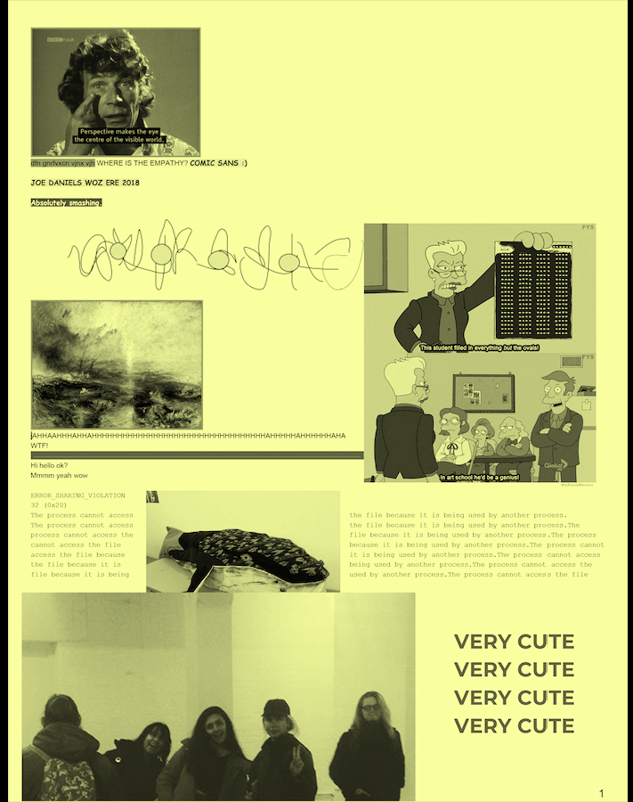

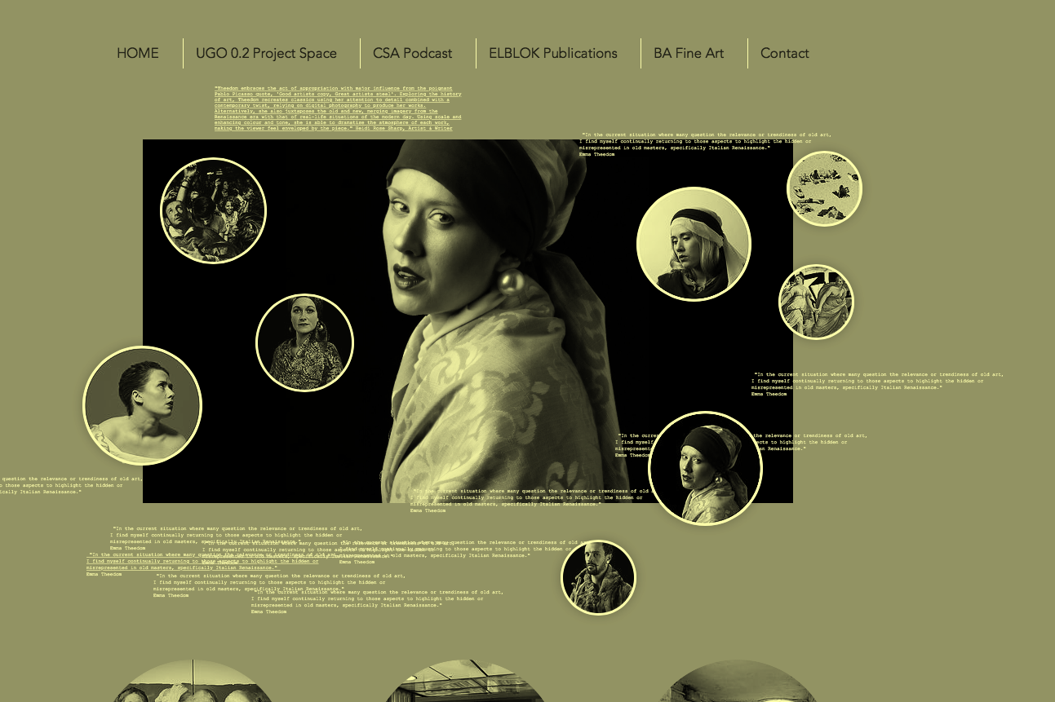

CERTIFIED COPY

Emma Theedom |
Curated by Íris D Gunnarsdóttir & Jonathan Kelham |
November 2018
www.uccfineart.com/emmatheedom-certifiedcopy

Ctrl+C Ctrl+V

INTENTION:

Developed at the start of the academic year alongside Doc 0.1, the second project Certified Copy was launched as part of UGO 0.2 Digital Project Spaces’ 2018-19 programme. The intention of this project was to develop, in collaboration with co-curator Íris D Gunnarsdóttir [BA [HONS] Fine Art 3rd Year Student], a re-curation, presentation and documentation of a body of work known to the student cohort. Informed by refined and engaging online presentations by Legion Projects including Reliable Communications [2014] by Yuri Pattison.

This would provide the incoming second + third-year cohorts with a knowledge and awareness of the transition from a series displayed physically as part of the undergraduate degree show Unfinished Business and the reimagination of the work in the project to a web space. Becoming a more resolved and ‘finished’ project could provide contrast to the ambiguity of DOC 0.1. Certified Copy would also demonstrate the potential to represent works to inform new or more expansive experiences digitally, feeding into the internets’ potential to professionalise art practice in documentation and promotion.

PROJECT:

UGO 0.2 welcomed the BA (Hons) Fine Art graduate artist Emma Theedom,
Certified Copy is a contemporary online exhibition, where you can explore the artists art practice, written work and discover relevant websites to Theedom’s work by clicking and scrolling. Use this exhibition as a playground to learn and explore the opulent works of this Essex based artist.

"Theedom embraces the act of appropriation with major influence from the poignant Pablo Picasso quote, 'Good artists copy, Great artists steal'. Exploring the history of art, Theedom recreates classics using her attention to detail combined with a contemporary twist, relying on digital photography to produce her works. Alternatively, she also juxtaposes the old and new, merging imagery from the Renaissance era with that of real-life situations of the modern day. Using scale and enhancing colour and tone, she is able to dramatise the atmosphere of each work, making the viewer feel enveloped by the piece." Heidi Rose Sharp, Artist & Writer

UCCFineArt.com is best viewed on laptops/desktops using a ‘modern’ browser.

RESEARCH OUTPUT:

Key success of the project included the interview of Theedom instigated and conducted by Gunnarsdóttir, alongside the collaboration with Sharp to produce a text to accompany the project.

TRIPLE THREAT

Íris D Gunnarsdóttir, Heidi Sharp & Charlotte Cawdry |
Curated by Jonathan Kelham |
January 2019
www.uccfineart.com/triplethreat

1,2,3 …
​
INTENTION:

The direction of the third project was to present the curation of existing works in a group show of current students as part of UGO 0.2 Digital Project Spaces’ 2018-19 programme. Three students progressing onto the third year were selected, who had not previously experienced showing these works in a three-person context. Triple Threat was intended to provide these students with a new experience in displaying work, another’s curation of the work and the development of new narratives across the collaboration.

PROJECT:

From January 2019 UGO 0.2 welcomed three BA (Hons) Fine Art students Íris D Gunnarsdóttir, Heidi Sharp & Charlotte Cawdry, for the third curated digital project. Triple Threat has brought together selected works developed from their emerging second-year practices. The resulting project intends to present these separate research strands in a new framework, to consider visual and thematic conversations which can occur from reflecting and reimaging individual imagery and works in a more collective and interactive curation. The project was more playful with the interaction, providing hidden links to pages presenting the works in different compositions. The project also animated the predominantly still image submissions via timings to generate a pace to the project which was different to the previous two projects.

RESEARCH OUTPUT:

The development of the project from submission to curation and technical were slow and this resulted in a lessening of the impact of the project upon the emerging ideas across the initial phases of the academic year. The hidden elements of the project were interesting additions, but they also provided a barrier to the accessibility and initial reaction to the project, this resulted in a lower interaction [statistically] and a higher bounce rate of the project.

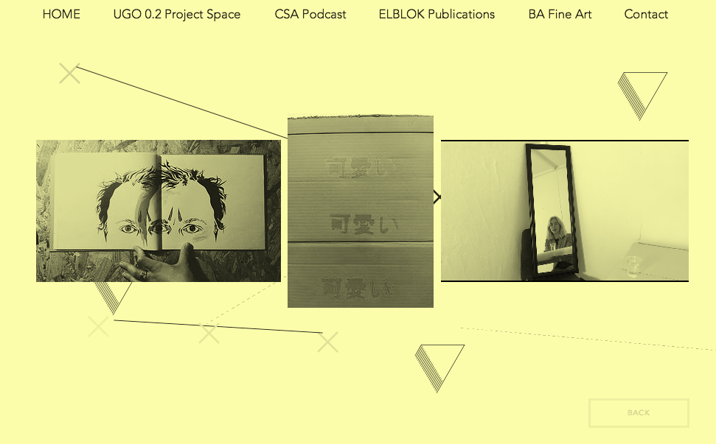
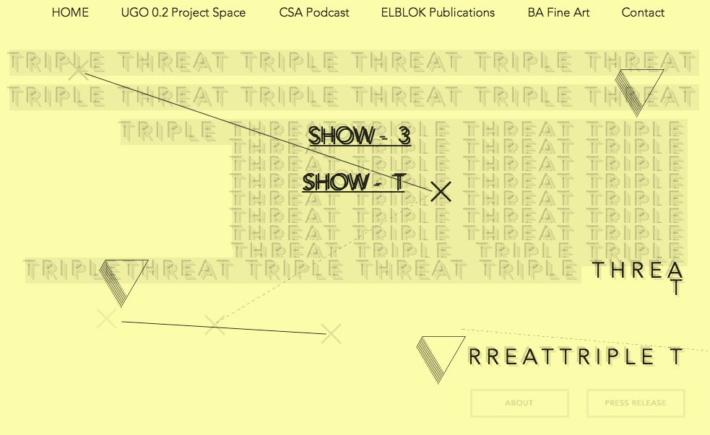

HANDLE THIS

Olivia Bax |
Curated by Íris D Gunnarsdóttir |
May 2019
www.uccfineart.com/handle-this-olivia-bax

My Sculpture Is Physical

INTENTION:

The initial context for this commission was to compliment the student and workshop strengths on the BA Fine Art programme, which are predominantly aligned to more traditional processes and material-based arts practices. Sculptor Bax was approached as an established artist known for her interest in materiality, creating large-scale sculptural forms which have a strong textural surface and a strong physical connection to the artist. UGO 0.2 was interested in how an artist working in such a field would respond to the framework of the digital.

In the development of this year’s programme of projects, UGO 0.2 developed a number of questions to instigate projects: How is UGO 0.2 and by extension the digital project space relevant to the student-artist dealing almost exclusively in the physical, as the sculptor-fabricator-ceramicist etc?

“In the studio, making work involves a series of actions: some planned, some responsive. Handle This is a recording of a simple action, one of many to complete a sculpture. In this .gif I was preparing the surface of a part of a sculpture in preparation for a ready-made handle. “ Olivia Bax Handle This Text 2019

PROJECT:
UGO 0.2 welcomes artist Olivia Bax, for the fifth curated digital project in the 2018-19 programme.
In discussion with Gunnarsdóttir, Bax selected a new process in which to develop the work for the project, an animated response to the physical process she repeatedly undertakes as part of her sculpture making. The resulting looped .gif artwork focused on the preparation of a sculptures surface for a ready-made handle, a reoccurring motif in Bax’s work. As Bax describes ‘The loop acts as an important tool to see that the changes in speed are not an error in the file but deliberate. In the studio, things might slow down, and speed up again but an artist’s work never stops…’ Olivia Bax Handle This Text 2019

RESEARCH OUTPUT:

The authenticity of the selected artist in approaching the project was central to the success and engagement of the project in the context of the cohort. Students were able to appreciate the sculptural interests and concerns [knowledge gap, risk taking etc.] of Bax, whilst the projects central works; a .gif and print demonstrated a synthesis of these two elements [sculpture and risk].
_ _ _ _

OLIVIA BAX
www.oliviabax.co.uk

Olivia Bax lives and works in London. She studied MFA Sculpture at Slade School of Fine Art, London (2014-2016). Recent solo exhibitions include: Roost, Lily Brooke Gallery, at large, VO Curations, London (2018). Bax's interest in the process of making leads to producing her own construction material. Surface and texture often inform her choices as she fashions a language rich in marks, signs and repetition.
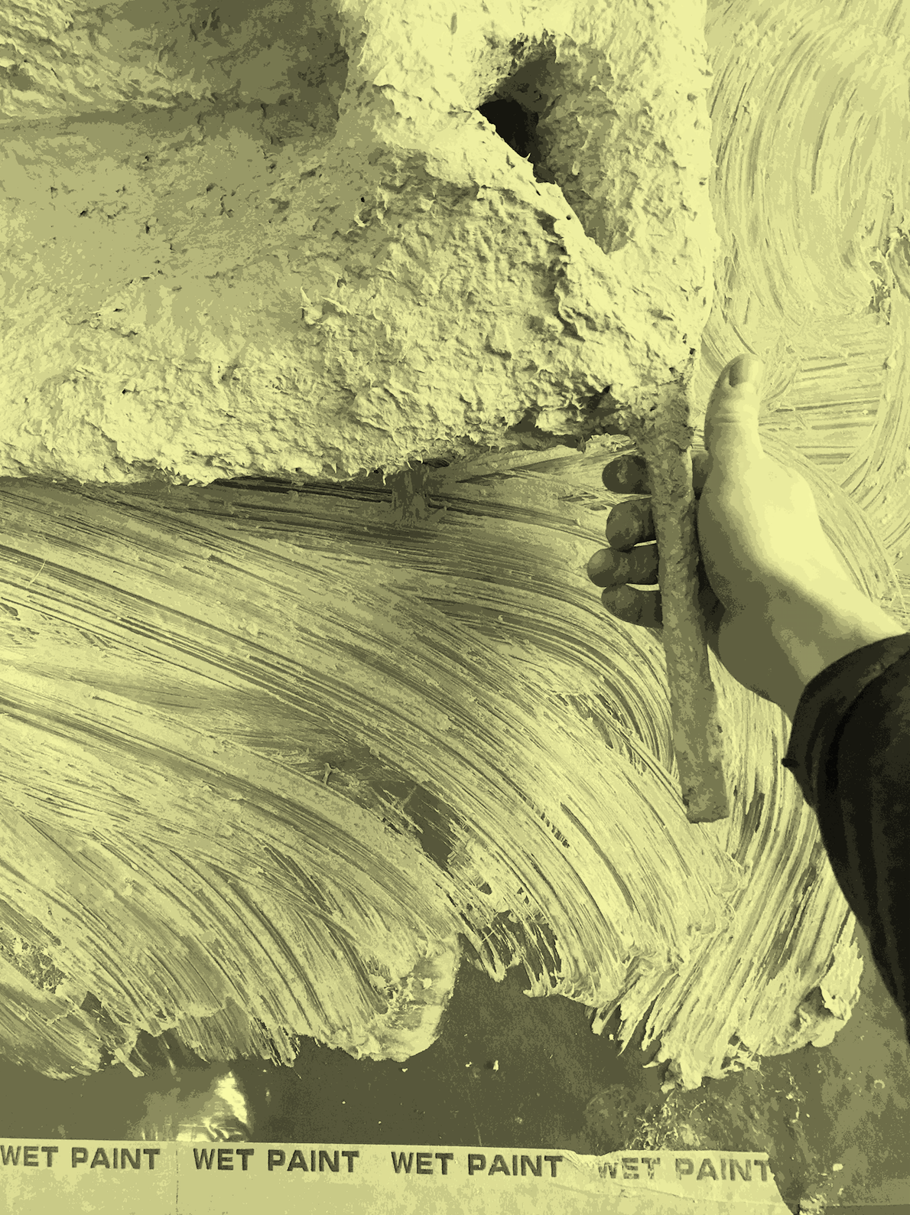

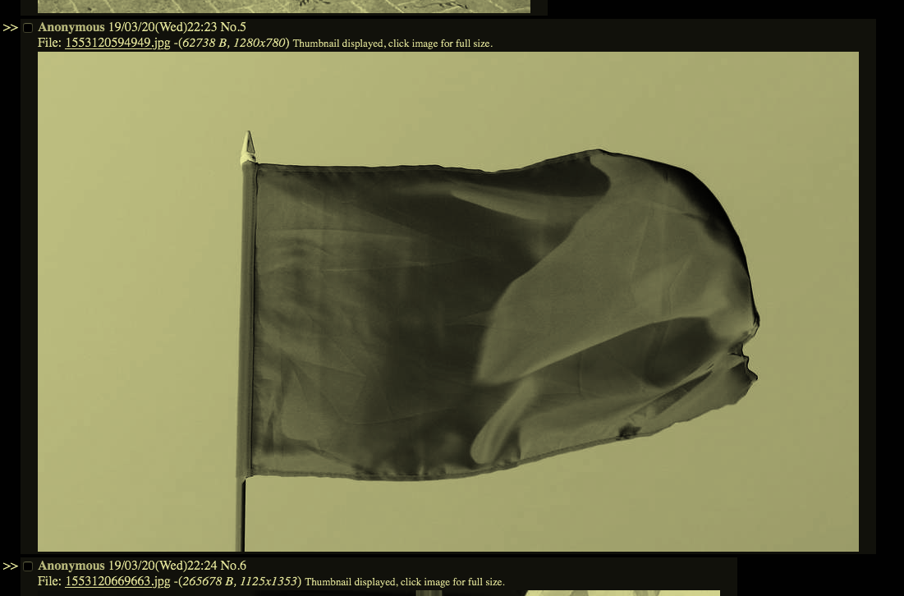
SIMILITUDES

BFA 3 | Charlotte Cawdry, Íris D Gunnarsdóttir, Deborah Lander, Kayleigh Reed,
Susie Scott, Heidi Sharp, Shane Wimbledon and Beckie Yates. |
Curated by Dave Evans |
April 2019
www.uccfineart.com/similitudes-dave-evans

The Digital Divide

INTENTION:

The initial proposal of similitudes was to provide a new opportunity for students to investigate the potential of digital collaborations and to consider the digitalisation of their predominantly physical art practices, and by extension an awareness of networking, collaborative curation and critical frameworks.

PROJECT:
In Similitudes UGO 0.2 welcomed a collaboration between eight BA (Hons) Fine Art 3rd Year students and artist/curator Dave Evans, for the fourth curated digital project.
Similitudes brought together a completely remote, internet-based group project curated by Dave Evans, taking work in progress as a loose framework for submissions and the resulting conversations exhibited online at UGO 0.2.

The outcome was a series of images from which the curator felt disconnected and unresolved. Evans, confronted by this unusual position of ‘encountered images’, has taken a line from Claire Bishops Artforum essay ‘The Digital Divide’ [2018] ‘can communication between users become the subject of an aesthetic’ as a format for the curation, via exchange between curator and artists. So maybe the exchange between curator and artist could be the exhibition itself, rather than plucking an aesthetic out of thin air?

RESEARCH OUTPUT:

Similitudes became the result of such an exchange, on a chan-style message board at http://ffzzgg.net/UGO/.
_ _ _ _

DAVE EVANS
www.evansdave.com

Dave Evans is an artist and researcher based in Liverpool, UK. He makes Wireless Local Area Networks to explore the potential in creating DIY, personal and communal platforms for sharing information. He is working towards a PhD Online Asceticism as Emancipatory Digital Practice, in the Visual Cultures department at Goldsmiths, University of London, speculating on how historical asceticism might influence contemporary digital networks.

THE UNION OF HUMAN INTELLIGENCE TASKWORKERS

Chris Alton |
Curated by Jonathan Kelham |
May 2019
www.uccfineart.com/the-union-of-h-i-t-chris-alton

The Wild West of Digital Labour
INTENTION:

The initial context for this project, within the wider remit of UGO 0.2, was to develop a commission which investigated the potential of collaborative practices and environments from a digitalised, internet-based perspective.

Alton, who’s previous expansive and holistic collaborative works include English Disco Lovers [EDL], proposed a project from an ongoing interest with the lack of collective organising power; workers benefits and employer rights of Human Intelligence Task [HIT] workers.
PROJECT:
UGO 0.2 welcomes artist Chris Alton, for the sixth and penultimate curated digital project in the 2018-19 programme. The commission has employed [for a living wage of £10.00 p/hour, which is substantially higher than rates paid on MTurk.] a small group of Amazon Mechanical Turk (MTurk) HIT workers to collaboratively design a union banner about their working conditions. The HIT workers, conducted research, exchanged notes and drawings, and offered feedback on the banner's design as it developed.
Alton conceived the project as a possible avenue for dissent and solidarity for the HIT workers. The Union of Human Intelligence Taskworkers reveals their working conditions to a wider audience, whilst also commenting on broader issues regarding precarious labour, automation, and trade/workers unions in the digital age.
RESEARCH OUTPUT:
The resulting project presented the realisation, at an early stage, of the wider collaborative potential between Alton and HIT workers. Initial plans to render the banner as a looped film were unachievable within budget and would have been a strong addition to the works quality on collective power and heroism. However, TUOHIT demonstrates the potential of working effectively and purposefully in, and for, a digital era.
_ _ _ _

CHRIS ALTON
www.chrisalton.com

Whether deploying disco music in opposition to fascism, recording a rhythm ‘n’ blues album about tax avoidance, or proposing art schools be built over golf courses, Alton’s work addresses the interconnected nature of prevailing social, political, economic and environmental conditions.

In 2012 Alton founded English Disco Lovers (EDL), a protest group that looked to reclaim the ' acronym of the English Defence League. The project involved; online occupations, street-level protests, club nights, talks and exhibitions.
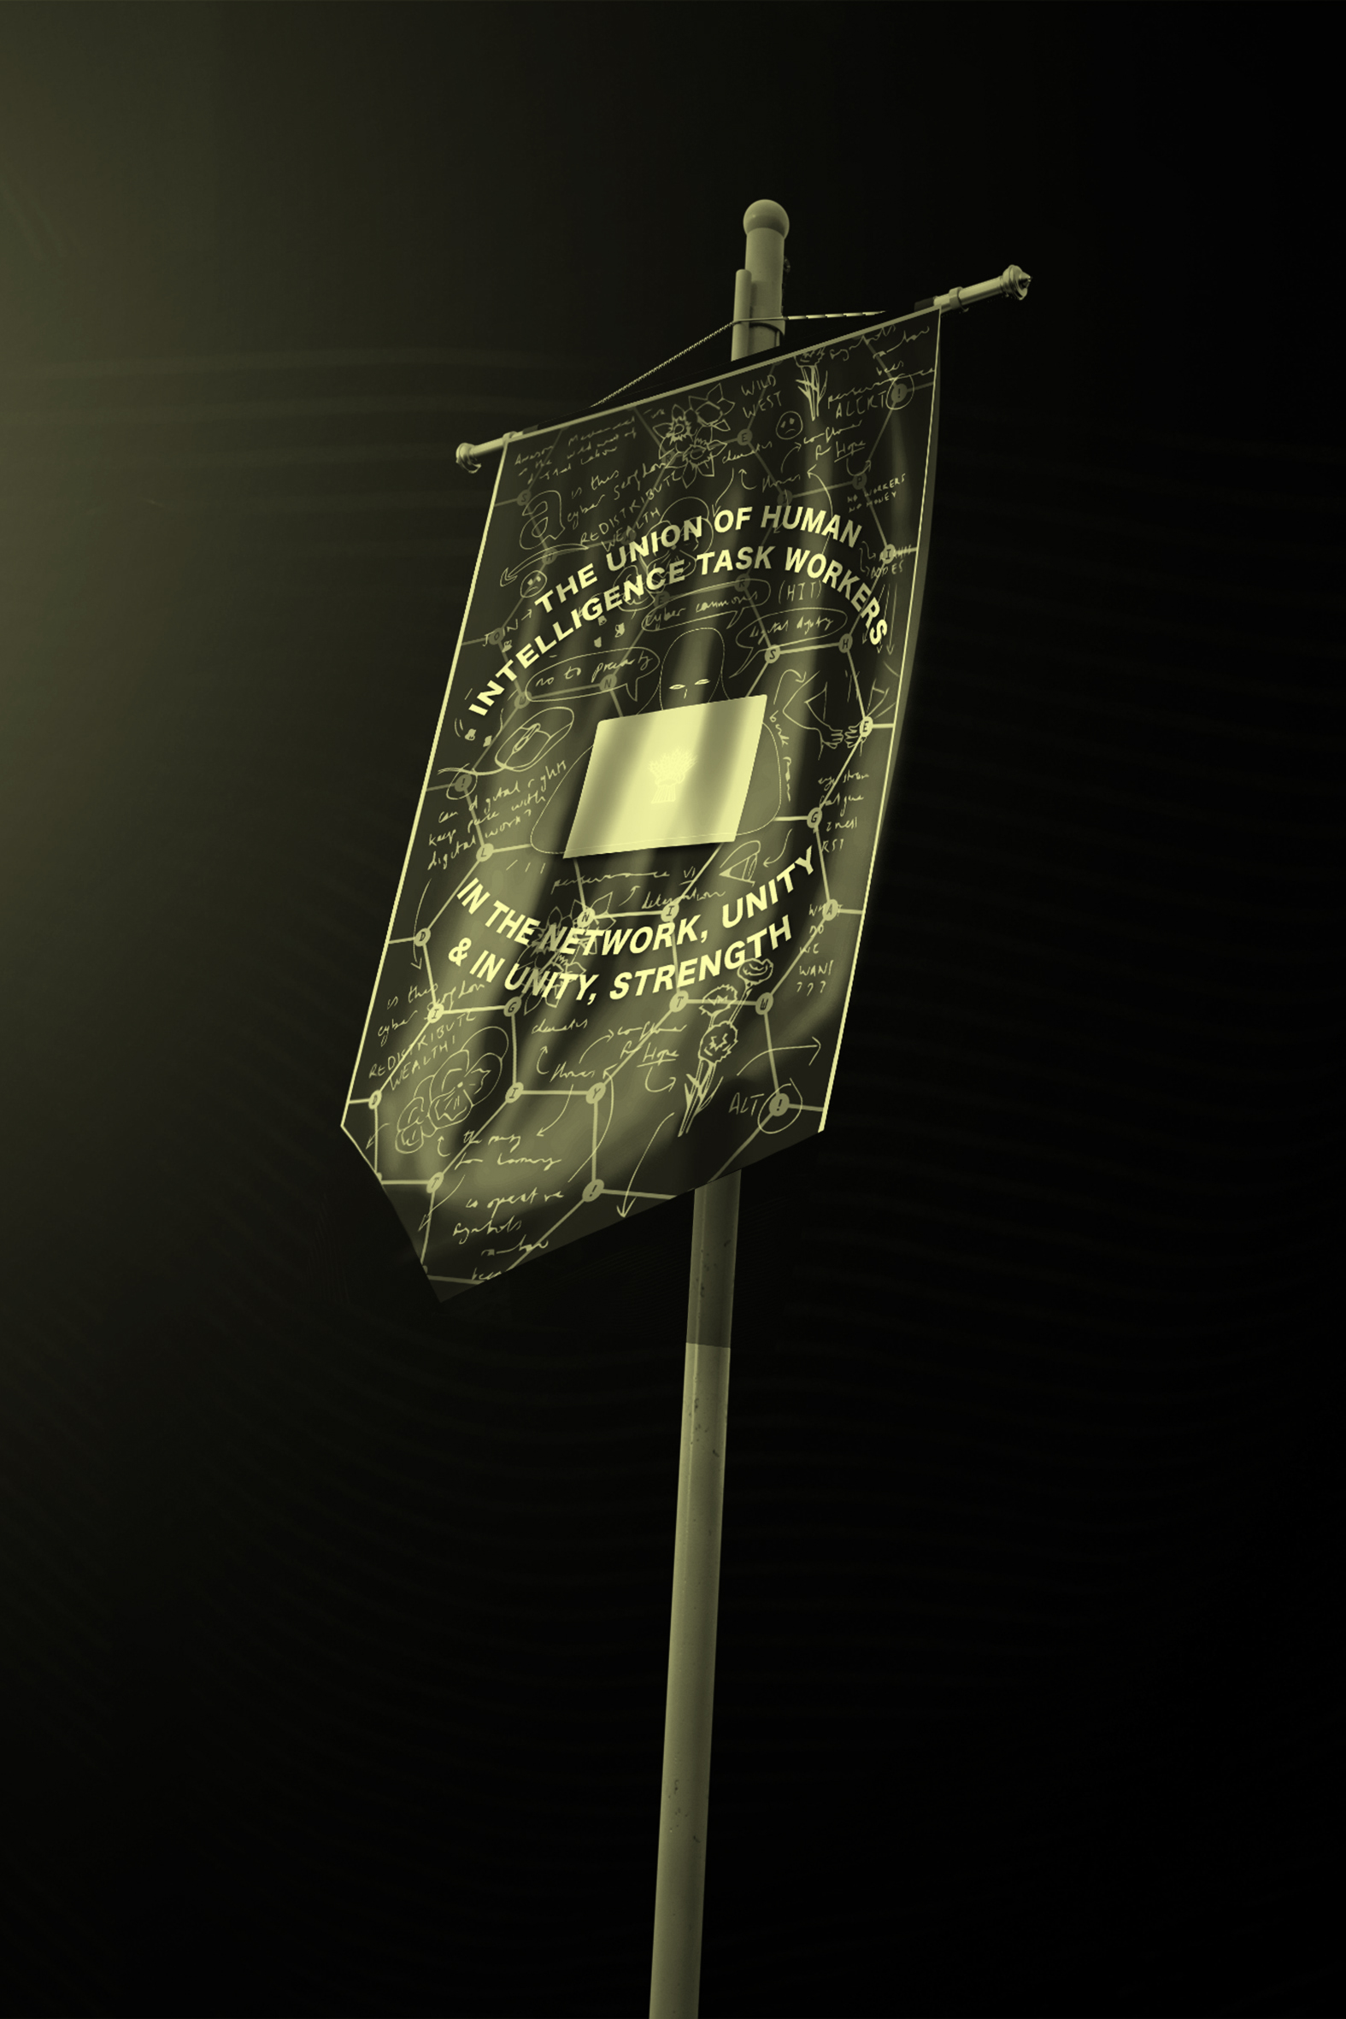
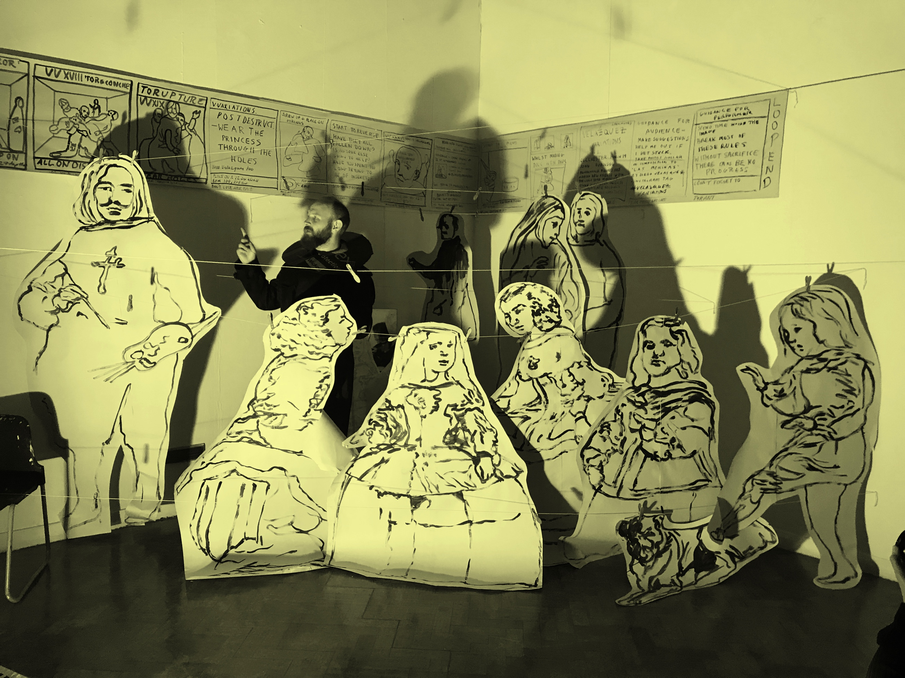
VELÁZQUEZ VARIATIONS

John Robinson |
Curated by Jonathan Kelham |
June 2019
www.uccfineart.com/

The Ladies in Waiting
INTENTION:

The final commissioned project for UGO 0.2’s 2018-19 programme responded to the specialist research and unique experience of performance as process. This gap in curriculum knowledge was identified and painter John Robinson was commissioned to undertake a performance in the School of Arts, Hay Gallery, allowing students to experience, first hand a rigorous performance with a clear context and rational. Robinsons practice utilises performance and photography to develop a plethora of imagery, compositions, narratives and surfaces which generate new painting works. Following on from a gallery visit to Division of Labour to view a performative interview by Mark McGowan [The Artist Taxi Driver], there were a number of questions raised by students about the suitable use of performative processes in their individual practices.
PROJECT:
UGO 0.2 welcomes artist John Robinson, for the seventh and final curated digital project in the 2018-19 programme. The commission Velázquez Variations investigated the complex, cinematic, multi-perspective painting Las Meninas [1656] by Diego Velázquez. In the performance Robinson draws upon the uncertain relationship between the figures depicted, artist and audience, encouraging audience participation, documentation and support as he reworks and poses, capturing snapshots of an idiosyncratic retelling. Looped audio, mangled life size inked figures from Las Meninas, a single mirror and a temporary hanging system generate documentation for potential paintings to be developed by Robinson upon return to the studio.
RESEARCH OUTPUT:
The significant amount of visual and audio material recorded from the performance, as part of the process, has proved a diligent selection process. Typically, Robinson’s performances remain as processes of working out, left in the studio, with the paintings the resolved focus. Via a series of interactive and overlapped 360° imagery, still photography and the looped audio, the project has documented the process to imitate the immersive, disorientating and illusionary qualities found in viewing Velázquez Variations and Las Meninas,
_ _ _ _
JOHN ROBINSON
www.johnmrobinson.uk
John M Robinson makes paintings of photographs and films that he has taken of performances he does in museums and galleries both nationally and internationally. He uses painting as a tool to draw our attention to a single moment and has faith that the moment will hold inside it the whole great mess of a story.
Robinson always paints himself as a character; the prophet Jonah, the father of Hansel and Gretel, the time travelling artist Albrecht Durer, and now as two people, the demon librarian Holofernes Finter and his master Sir Richard Croft. Robinson has a poor memory and an over active imagination resulting in stories being half remembered, falsified and mythologized.
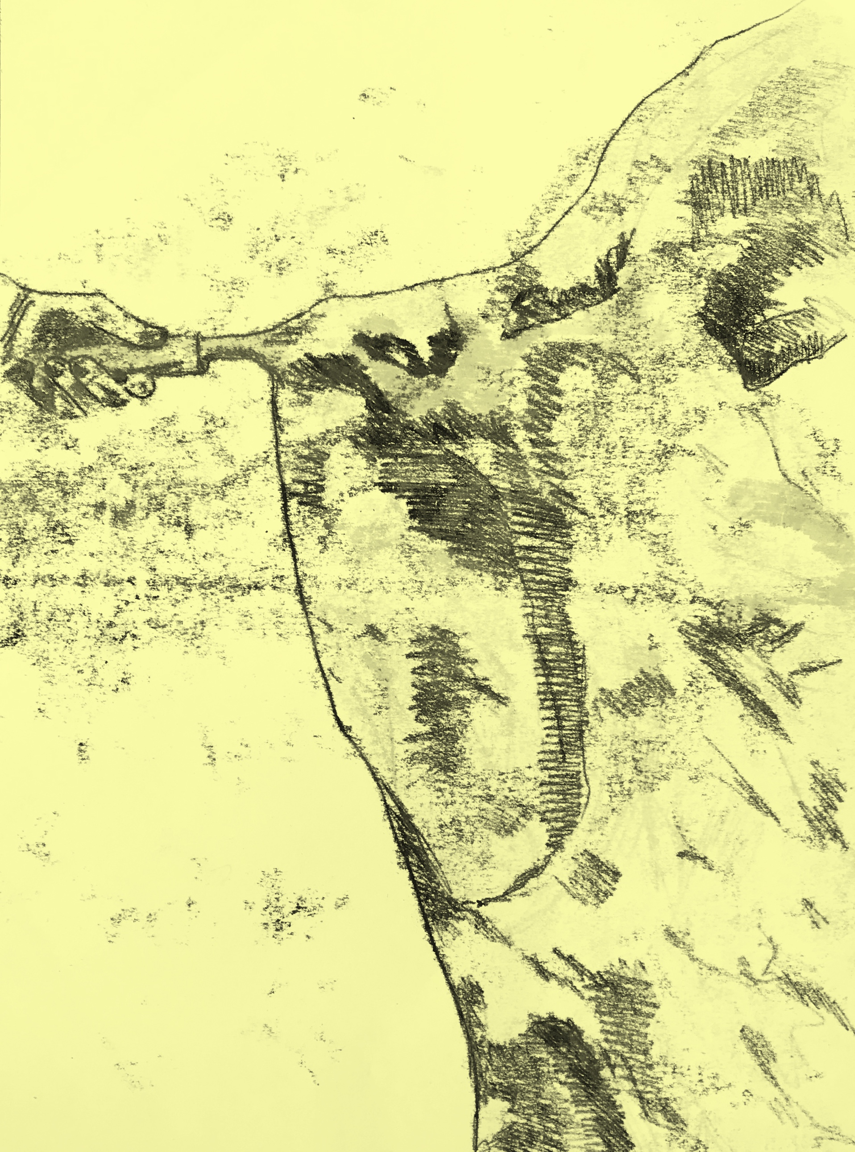

UGO 0.2
Project Space

BA [Hons] Fine Art
University Centre Colchester
School of Art
_ _ _ _
.
The coordinators of the UGO 0.2 Digital Project Space 2018-19 programmes were:

Jonathan Kelham
BA [HONS] Fine Art Course Leader
+
Íris D Gunnarsdóttir
BA [HONS] Fine Art 3rd Year Student

